Petra – City of Pink Stone

You always come to Petra from the east, and you always come on foot – or perhaps on a camel. The road to Petra is too narrow for a car. For the last two kilometres, you travel through a mountain, and the road is only five metres across. But the walls on both sides of the road are hundreds of metres high. This is the entrance to Petra, and it is called the Siq.
When you visit Petra, you walk through the Siq. And when you come to the end of the Siq, you see the most beautiful building in the world. It is called the Khazneh (the Treasury). It is tall, and it is made of pink stone – but you can only see the front of the Khazneh. The rest of the building is inside the mountain. People made the building two thousand years ago, but they did not build it – they cut it into the mountain.
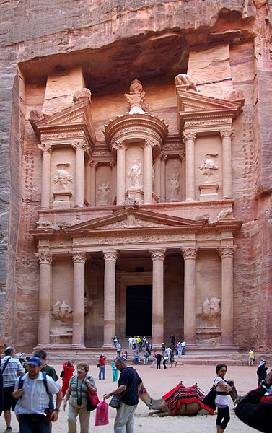 About 2,500 years ago, a group of Arab people moved to south Jordan. They made their capital city at Petra, in the mountains. It was a good place for a city. First, it was good place for a market. Petra was on the old road between Egypt and Arabia (to the south) and Syria, Greece, and Rome (to the north). Travellers came along this road with things to sell, like gold and spices. Second, it was a good place to defend. The mountains around Petra were stronger than any walls. And third, there was water. The people who settled there made dams to hold the water, and canals to move it around the city. Two thousand years ago, Petra was a rich and important city with strong, beautiful buildings, and thousands of people living there. Now no one lives there, and the city has gone.
The building of the city began in about 400 BC. In the year 363 AD there was a terrible earthquake which destroyed much of the city. Two hundred years after that, in 551 AD, there was another bad earthquake. People moved away from Petra, and they stopped using the road for business. They began to use ships – not camels – to carry their spices and gold. And the world forgot about Petra for more than a thousand years. But Petra is still there. The earthquakes destroyed the buildings on the land, but they did not destroy the buildings in the mountains. Many of these beautiful buildings are tombs – places for dead bodies. They are empty now, but you can still visit more than 500 of them. At the far end of Petra is a tomb called the Monastery, which is 50 metres high. But it is the beautiful pink stone front of the Treasury that is in everybody´s photos of Petra.

(Adapted from: Newbolt, B.: World Wonders. OUP. Oxford 2011.)
(Figure from: http://en.wikipedia.org/wiki/File:Petra_Jordan_BW_21.JPG; Berthold Werner, November 10, 2008 )

Task 1:
Explain the following facts from the text:
Siq – Khazneh – 2,500 years ago – 2,000 years ago – 400 BC – 363 AD -551 AD – 500 – 50 metres

Task 2:
Rewrite the following statements to make them correct:
- You can drive to Petra.
- Siq is the most beautiful building in the world.
- The Treasury is quite low and you can see it from all sides.
- The Treasury was built 2,000 years ago.
- Petra was easy to attack from all sides.
- There was no water at Petra.
- There are many beautiful buildings at Petra – old houses for people.
- There is a big treasure inside the stone urn at the top of the Treasury.

Task 3:
Make a simple time line of the existence of the city of Petra.

