R. Dahl´s RevoltingRhymes

Task 1 – Read the information about Roald Dahl and show important palces (highlighted in the text) of his life in the map
Roald Dahl was born in 1916 in Wales of Norwegian parents. He spent his childhood in England and was educated at Repton. At eighteen he went to work for the Shell Oil Company in Africa. Roald Dahl is one of the most successful and well known of all children´s writers. His books are read by children the world over. Roald Dahl died in 1990 at the age of seventy-four.

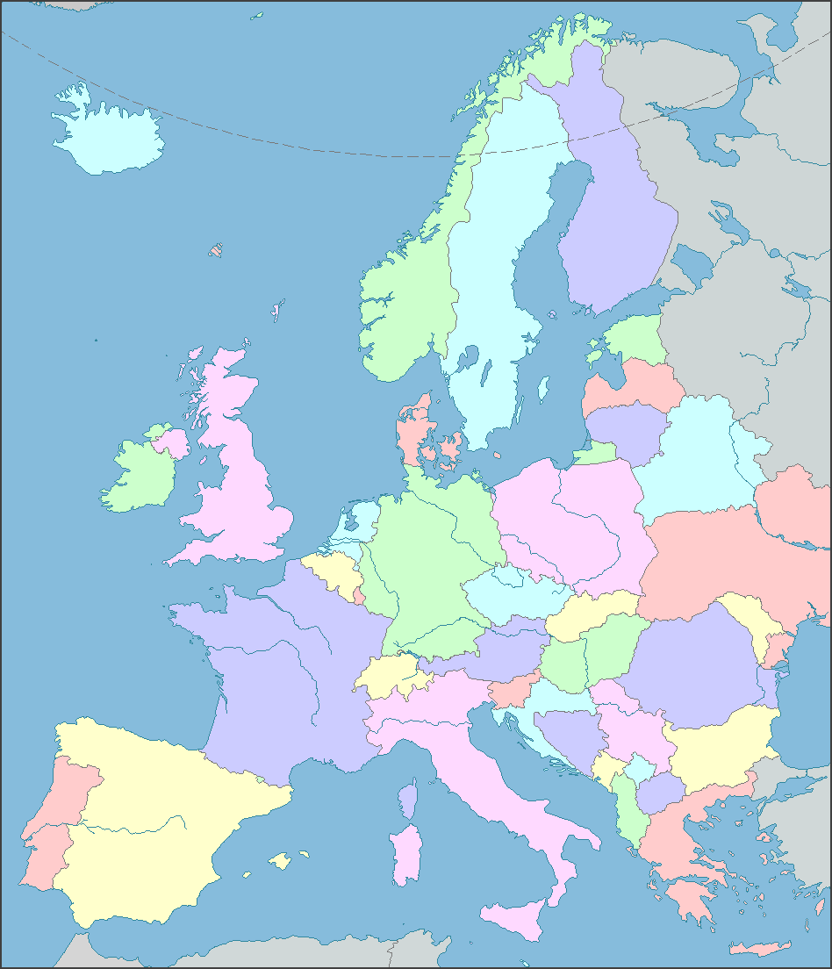
Vyznačení Anglie, Walesu a Norska na mapě Evropy.

Task 2 – work with your partner – divide the following book annotations into 2 halves and each of you read one half; choose two-three which you would like to read – tell your partner why and describe the plots to him/her:
Some of the books by R. Dahl are as follows (short summaries are taken from the back covers of the respective books published by Puffin Books):
1st part:
Charlie and the Chocolate Factory Charlie Bucket loves chocolate. And Mr Willy Wonka, the most wondrous inventor in the world, is opening the gates of his amazing chocolate factory to five lucky children. It´s the prize of a lifetime! Gobstoppers, wriggle sweets and river of melted chocolate delight await – Charlie needs just one Golden Ticket and these delicious treats could all be his.
The Giraffe,and the Pelly and Me Billy biggest wish is to turn a weird old wooden house into a wonderful sweet shop. But then he finds a giraffe, a pelly and a monkey living inside – they´re the Ladderless Window Cleaning Company! Who needs ladders when you´ve got a giraffe? They become best friends and when they meet the richest man in all of England, there´s a chance that Billy´s scrumptious galumptious dream just might come true…
Matilda Matilda Wormwood´s father is a mean crooked crook. And her mother´s just plain stupid. They think Matilda is a nuisance who should watch more TV and read fewer books! But her lovely teacher Miss Honey thinks Matilda is a genius. Matilda has a few extraordinary tricks up her sleeve, so her horrible parents and even more horrible headmistress had better watch out.
Boy Tales of Childhood Boy is the story of Roald Dahl´s very own boyhood, including tales of sweet shops and chocolate, mean old ladies and a Great Mouse Plot – the inspiration for some of his most marvellous storybooks in ht eyears to come. These tales are full of exciting and strange things – some funny, some frightening, all true.
2nd part:
The Witches Witches really are a detestable breed. They disguise themselves as lovely ladies, when secretly they want to squish and squelch all the wretched children they despise. Luckily one boy and his grandmother know how to recognize these vile creatures – but can they get rid of them for good?
The BFG Every night, when the world is sleeping, big gruesome giants guzzle up whoppsy whiffling human beans. And there´s only one giant who can stop them – the BFG. He´s the kindest giant there is and, with his friend Sophie in his top pocket, he sets out to rid the world of the Bloodbottler, the Fleshlumpeater and all their rotsome friends forever…
Danny the Champion of the World Danny thinks his dad is the most marvellous and exciting father a boy could wish for. Life is happy and peaceful in their gipsy caravan, until one day Danny discovers his dad has been breaking the law. What´s more, soon Danny has to join his father as they attempt to pull off a daring and devilish plot against horrible, red faced Mr Victor Hazell…
Going Solo This book tells of how, when he grew up. Roald Dahl left England for African and a series of daring and dangerous adventures began. From tales of plane crashes to surviving snake bites, read all about Roald Dahl´s life before becoming a world´s number-one storyteller.

Task 2 - Fill in the missing words of the fairy-tale, the lines rhyme:
Terrified; helping; tough; those; said; smiled; meal; hair; head; anyway.

As soon as Wolf began to feel
That he would like a decent MEAL,
He went and knocked on Grandma´s door.
When Grandma opened it, she saw
The sharp white teeth, the horrid grin,
And Wolfie said, ´May I come in?´
Poor Grandmamma was TERRIFIED,
´He´s going to eat me up,´ she cried.
And she was absolutely right.
He ate her up in one big bite.
But Grandmamma was small and TOUGH,
And Wolfie wailed, ´That´s not enough!´
´I haven´t yet begun to feel
That I have had a decent meal!´
He ran around the kitchen yelping,

´I´ve got to have another HELPING!´
Then added with a frightful leer,
´I´m therefore going to wait right here
Till Little Miss Red Riding Hood
Comes home from walking in the wood.´
He quickly put on Grandma´s clothes.
(Of course he hadn´t eaten THOSE.)
He dressed himself in coat and hat.
He put on shoes and after that
He even brushed and curled his HAIR,
Then sat himself in Grandma´s chair.
In came the little girl in red.
She stopped. She stared. And then she SAID,
´What great big ears you have, Grandma.´
´All the better to hear you with,´ the Wolf replied.
´What great big eyes you have, Grandma,´
Said Little Red Riding Hood.
´All the better to see you with,´the Wolf replied.
He sat there watching her and SMILED.
He thought, I´m going to eat this child.
Compared with her old Grandmamma
She´s going to taste like caviare.
Then Little Red Riding Hood said, ´But Grandma,
What a lovely great big furry coat you have on.´
´That´s wrong!´cried Wolf. ´Have you forgot
To tell me what BIG TEETH I´ve got?
Ah well, no matter what you say,
I´m going to eat you ANYWAY.´
The small girl smiles. One eyelid flickers.
She whips a pistol from her knickers.
She aims it at the creature´s HEAD
And bang bang bang, she shoots him dead.

Task 3 - Six lines are missing, i.e. this is not the end of the fairy-tale; try to brainstorm what the very end of the story may be.
Jakékoli nápady na zakončení bez nutnosti rýmovat. Pozor na přemíru agrese a násilí.
A few weeks later, in the wood,
I came across Miss Riding Hood.
But what a change! No cloak of red,
No silly hood upon her head.
She said, ´Hello, and do please note
My lovely furry WOLFSKIN COAT.´

Task 4 – What question did Little Red Riding Hood forget to ask the Wolf/Grandma?
´What great big teeth you have, Grandma,´ nebo jakékoli jiné mluvnicky a významově správné varianty

Task 5 – What did the Wolf do to look like LRRH´s Grandmother?
He quickly put on Grandma´s clothes.
(Of course he hadn´t eaten THOSE.)
He dressed himself in coat and hat.
He put on shoes and after that
He even brushed and curled his HAIR,
Then sat himself in Grandma´s chair.
Nebo jakékoli jiné správné odpovědi postihující všechny skutečnosti. (He put on Grandma´s clothes. He put on her shoes. He curled his hair. etc.

