Christmas
About 2,000 years ago, Jesus was born in the town of Bethlehem. At Christmas, people remember that special time. Today, Christmas is a very important time in the Christian year, but it is also very important to people who do not go to church. It is time for presents, parties, and time with the family.
People start to get ready for Christmas in late October or early November. They decorate their shops with lights, trees, and other decorations. Shops get very busy and stay open later. In the middle of December, most families buy Christmas trees, put them inside the house, and put colourful decorations on them. They also send cards to friends and family. The cards say things like Merry Christmas and a Happy New Year or Season´s Greetings. These two traditions (the trees and the cards) both started in the 19th century.
The Christmas holiday begins on 24 December: Christmas Eve. People often stop work early and have a drink together, or finish their Christmas shopping. Children leave a stocking for Santa Claus (called Father Christmas in Britain) when they go to bed. Santa is a big man with white hair and red clothes who brings presents for children during the night. Mothers and fathers tell their children that Santa only comes when they are sleeping. They also tell them that Santa leaves presents for good children – but for bad children he only leaves a piece of black coal!
Many people go to church at midnight on Christmas Eve. They listen to the Christmas story and sing carols. Next morning it is Christmas Day – 25 December. Children usually wake up very early. They look in their stockings to see the presents that Santa put there for them. After breakfast they open their other presents around the tree.
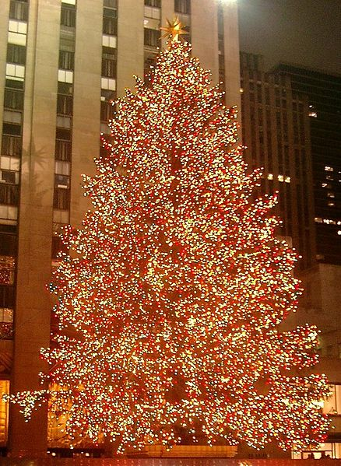Christmas dinner is in the afternoon and is the biggest meal of the day. Dinner is usually turkey with lots of winter vegetables and then a Christmas pudding. At 3 o´clock many people in Britain turn on their televisions because the Queen says Happy Christmas to everyone. A lot of people go for a walk in the afternoon or play with their new games. In the evening, people eat cold meat, and Christmas cake (a kind of fruit cake) but they are usually not very hungry because of their big dinner.
26 December is called Boxing Day (St. Stephen´s Day in Ireland). It is a holiday for many people, but a lot of shops open on this day. In 19th century, rich people gave boxes of presents to their workers on Boxing Day. Now people enjoy eating, drinking, and watching television at home, or going out to watch some sport. After Christmas the next festival comes very quickly. Soon it is 31 December. It is New Year´s Eve – and then a new year begins.
Adapted from: Maguire, J.: Seasons and Celebrations. OUP, 2008.
Figure taken from: http://en.wikipedia.org/wiki/File:Rockefeller_Center_christmas_tree_cropped.jpg; 2009-12-02
Klipart
Task 1 – Before reading the text brainstorm ideas about Czech Christmas traditions, names of days and typical food. Write this information to the table below. Then read the text and fill in the information about Christmas in the English speaking world.

 | Czech Christmas | British/American Christmas
Names of days | Dec. 24 –  Dec. 25 –  Dec. 26 – | Dec. 24 –  Dec. 25 –  Dec. 26 –
Typical food
Traditions
Special things
connected with
Christmas

What are similarities and differences between the two cultures and ways people celebrate Christmas?

Task 2 - True or False? Tick the right statements and correct the wrong ones:

- Many people go to church at midnight on Christmas Eve.
- 31 December is called Boxing Day.
- The Prime Minister says Happy Christmas to everyone on TV on Christmas Day.
- Christmas dinner is in the afternoon and is the biggest meal of the day.
- Mothers and fathers tell their children that Santa leaves presents for all children.
- Children leave a pair of trousers for Santa Claus when they go to bed.

Task 3 – To the space below write a letter to Baby Jesus/Santa Claus/Father Christmas and ask for some presents. Say why you should get the presents. Your teacher will provide you with some helpful vocabulary:

Task 4 – in the following word search find and cross out the words given below – they are written in all directions:

G A X I G O J D U L H K Y K P
N N N S R A F E P M M L R R Y
M A I G A M R C P U L A E B E
U C M D E D W O E O T S G X K
Z T O W D L B R H S E B N A R
G M N X O U B A Y N L Q I E U
X R T C F N P T T Q O U K V T
B L L O Z Q S I F L R V C S E
H T A E R W H O N X A X O W L
V H X N Z P A N G S C U T M D
G A H Y G F M S K B L F S G N
H C H R I S T M A S T R E E A
I W R E O T E L T S I M M B C
G Z D K H E K A L F W O N S T
R E I N D E E R M K J T D U K

ANGEL 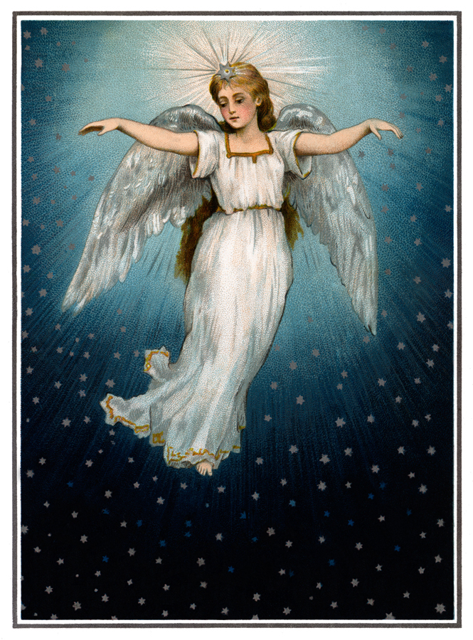– CANDLE 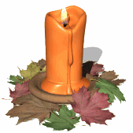– CAROL –
CHRISTMAS TREE 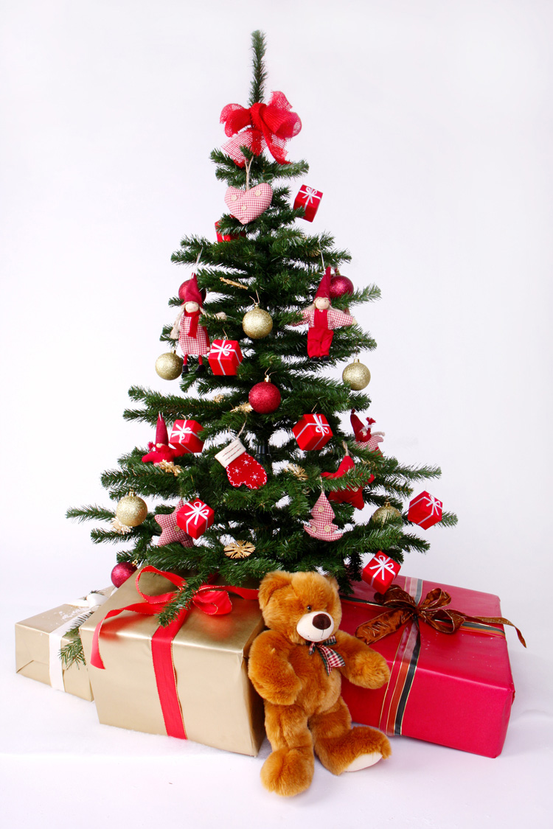 – DECORATIONS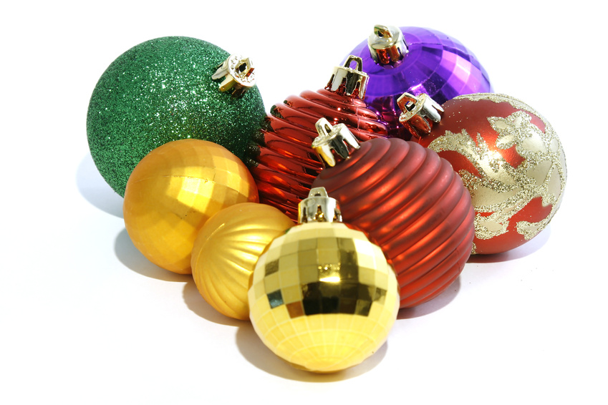– HOLLY – MISTLETOE 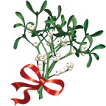– PRESENT 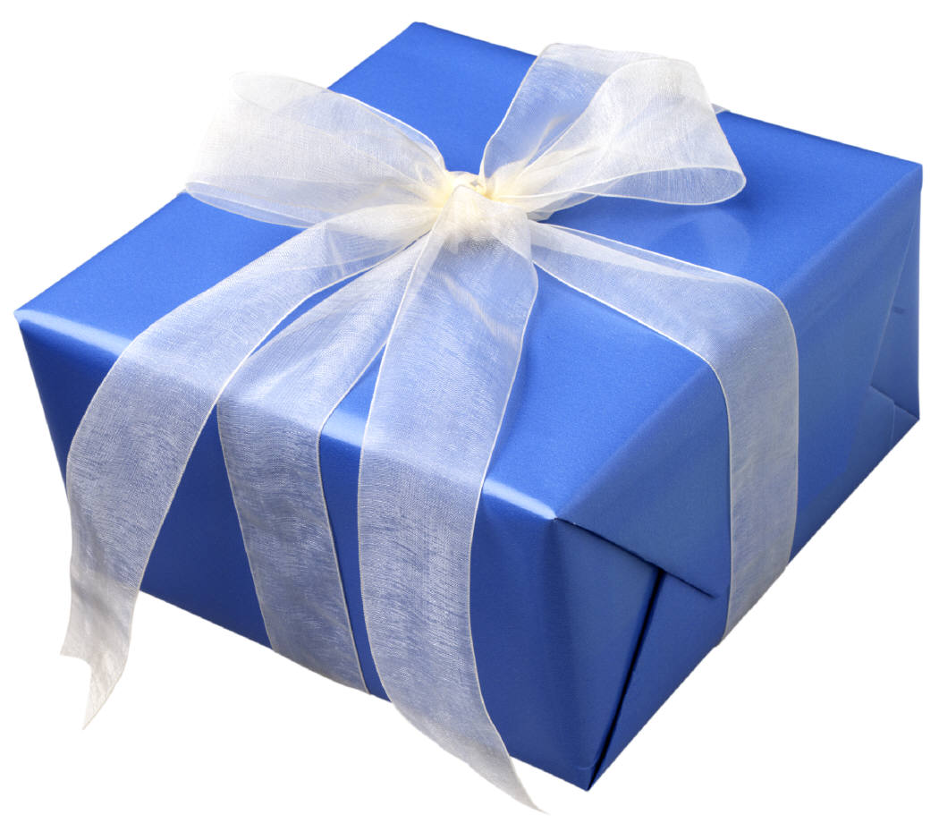 – PUDDING 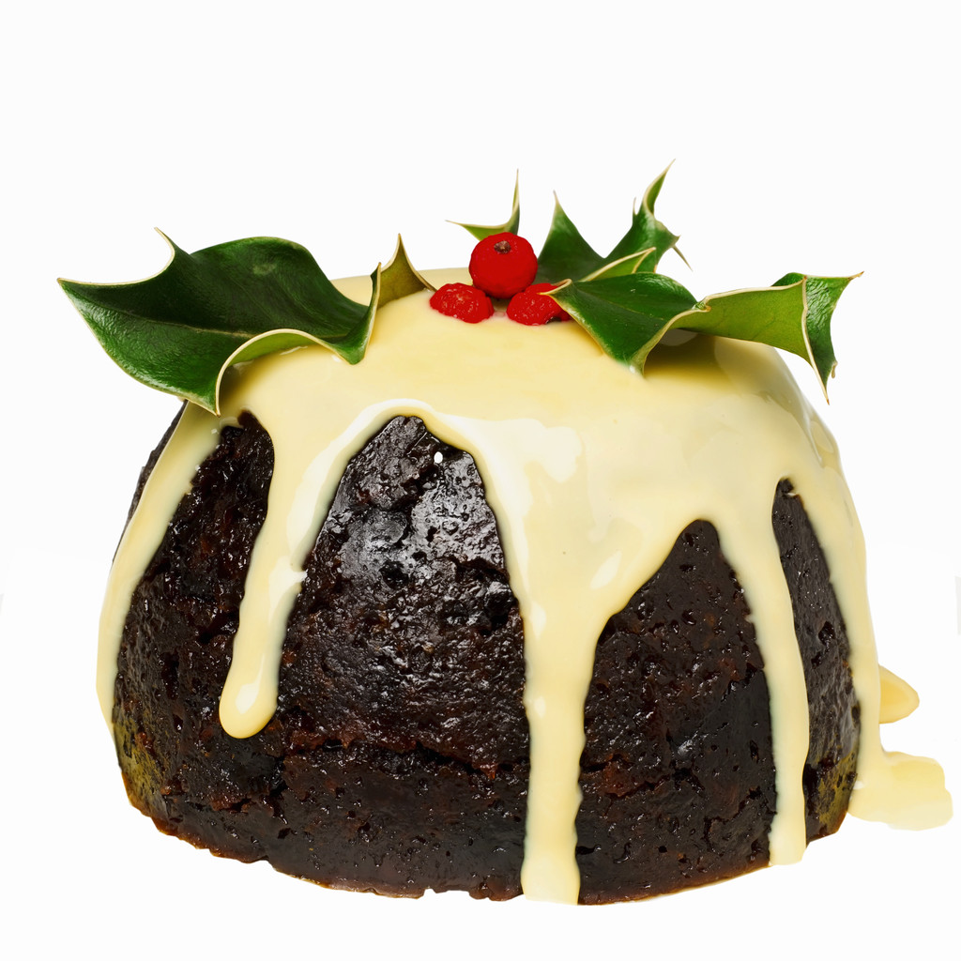 – REINDEER 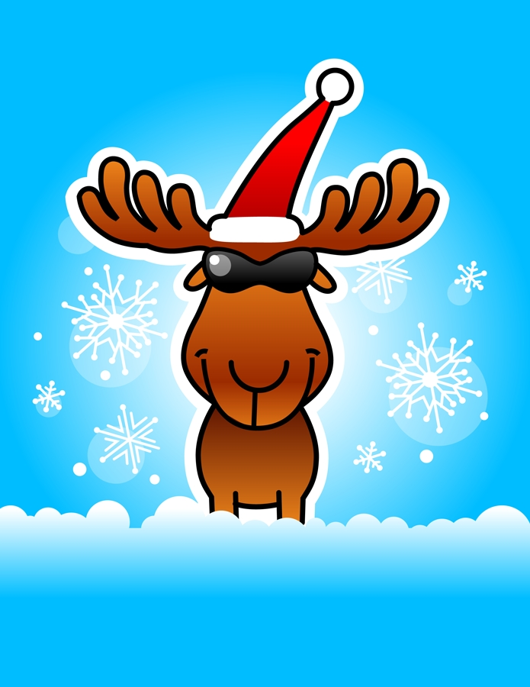 – SNOWFLAKE – SNOWMAN 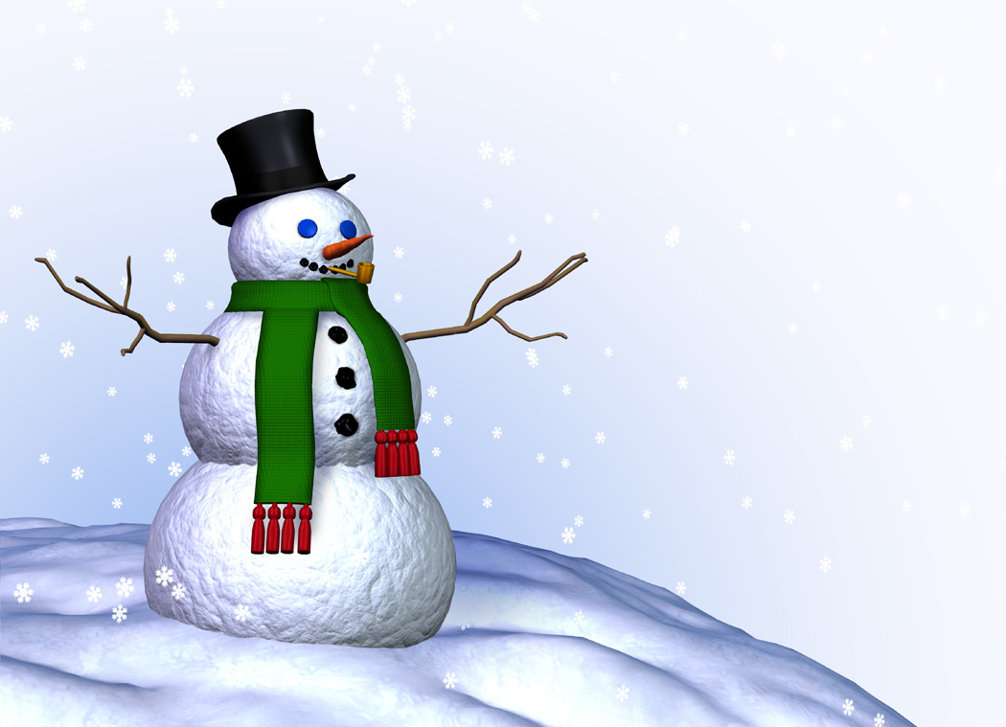–
STAR – STOCKING 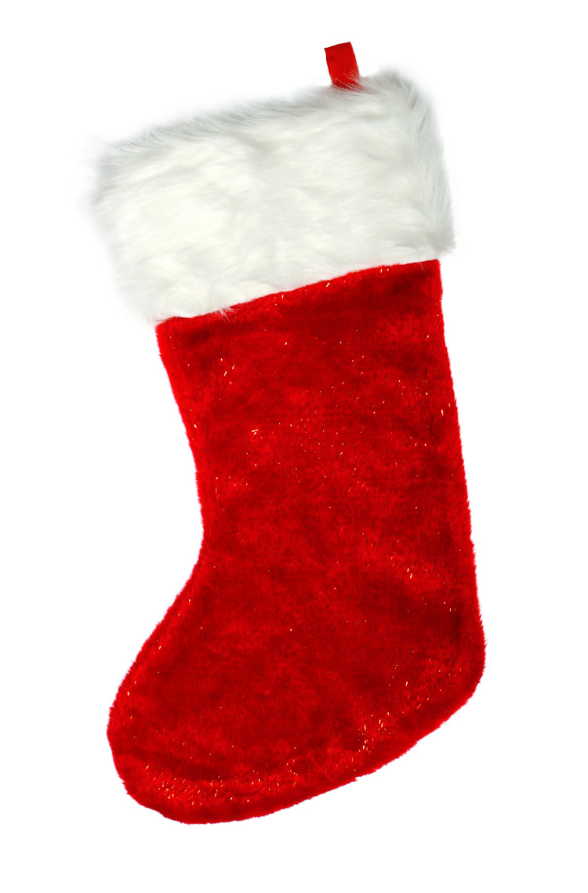– TURKEY -
WREATH 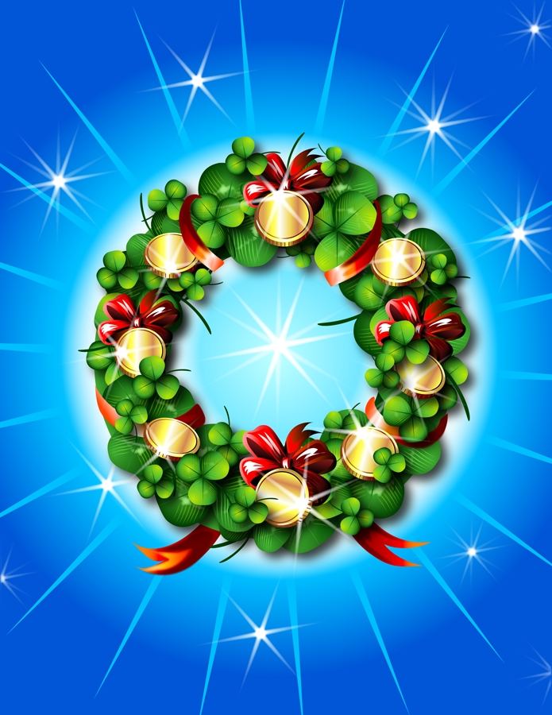

Pictures taken from Klipart.

