Summer Celebrations

The longest day of the year is called the summer solstice. In Britain, it is usually on 21 June, which is the first day of summer. The word solstice comes from two Latin words: sol, which means sun, and sistere, which means to stand still.
Summer was always a good season for people in the past, because it was easy to find food. It was also a good time to find sweet honey, so the first full moon in June is called the honey moon. Many men and women marry in June, and the holiday that people take after they marry is still called the honeymoon.
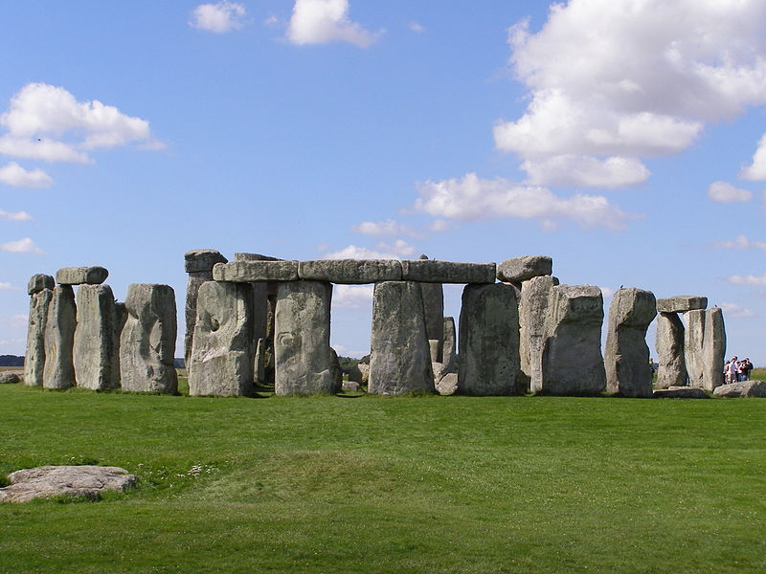At Stonehenge and Avebury inWiltshire, England, there are some special circles made of big heavy stones which have been there for about 5,000,000 years. Because the summer solstice is traditionally a time of sun, light, food, love, and hot weather, people come from all over England to Stonehenge and Avebury on 21 June to celebrate. Some of the visitors are Druids, who follow an old pagan religion, older than Christianity; some are travellers, who like to move around the country and live in lots of different places; and some just want to stay up all night and then watch the sun some up in a very famous, old and interesting place.
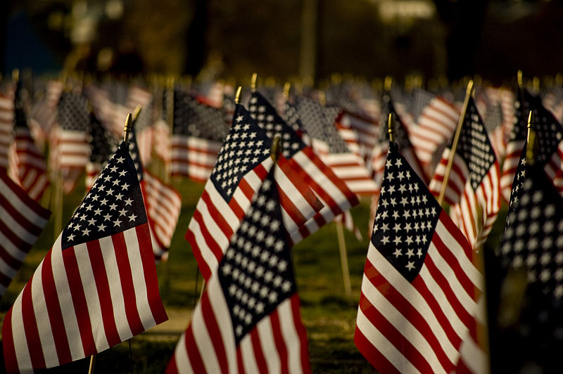Soon after the summer solstice there is an important date in the USA – the 4th of July. On July 4 1776, the United States government in Philadelphia agreed to the Declaration of Independence. This said that the United States was a free, or independent, country, and that George the Third was not its king any more. Now it was war. The British and the Americans fought each other until 1781, when the Americans won. In 1783 the United States of America was born. Every year on the 4th July, Americans celebrate Independence Day. There are special church services at this time, but most of the celebrations are outside because it is summer. Many families have a barbecue, eat, and play games in their gardens or in a park. In many towns, there are parades through the streets with loud music and lots of bright colours. The red, white and blue American flag flies everywhere. It has 50 white stars and 13 red and white stripes. The stars represent 50 states in the US, and the stripes stand for the first 13 states – the colonies. The flag has changed many times but today´s flag goes back to the 4th July 1960, when Hawaii became the 50th state.
Independence Day usually ends with lots of fireworks. It is like one big party.

Adapted from: Maguire, J.: Seasons and Celebrations. OUP, 2008.
Figures taken from:
http://en.wikipedia.org/wiki/File:Stonehenge2007_07_30.jpg; garethwiscombe, 30 July 2007
http://upload.wikimedia.org/wikipedia/en/2/20/Americanflags.jpg; Lipton sale, 12/1/2007

Task 1 – Read the text and tell your partner which two summer special days are described in it.

Task 2 – Choose one of the special days, read the text about it again, take notes while reading and then according to your notes describe it to your partner.

Task 3 – What are exact dates of summer and winter solstice and spring and autumn equinox?

June 21 or 22, December 21 or 22, March 20 or 21, September 22 or 23

Task 4 – according to the text give answers to the following questions:

- Who are Druids? People following old pagan religion.
- What is the origin of the Independence Day? Declaration of Independence signed.
- How many states constitute the USA? 50
- When did the last state join the USA? July 4, 1960
- How many stripes are there on the US flag? Why? 13, they represent original colonies/states on the Eastern coast of the contemporary USA

