The map of rainforests - teacher
Task 3 – label the places where the different tribes of rainforest people mentioned in the text live.

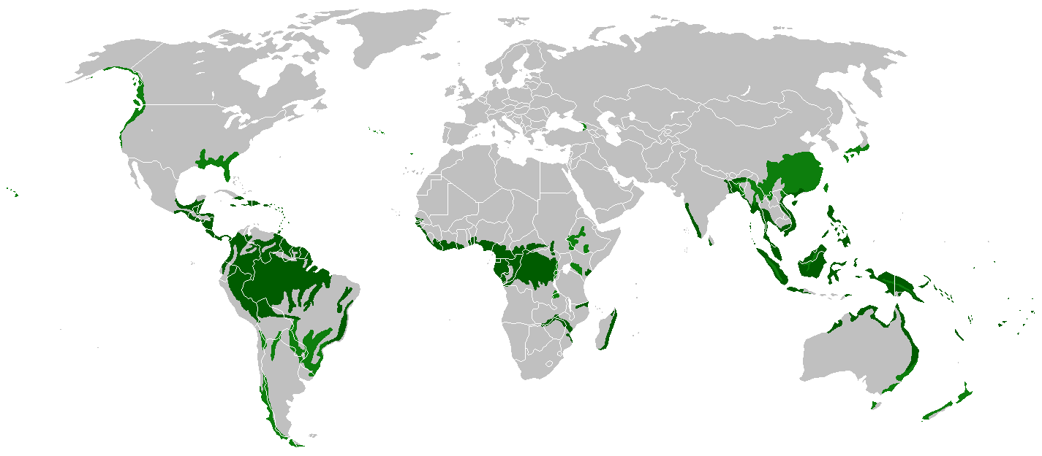

The Yanomami people
The Penan people
The Enawene Nawe people The Gavioes people

