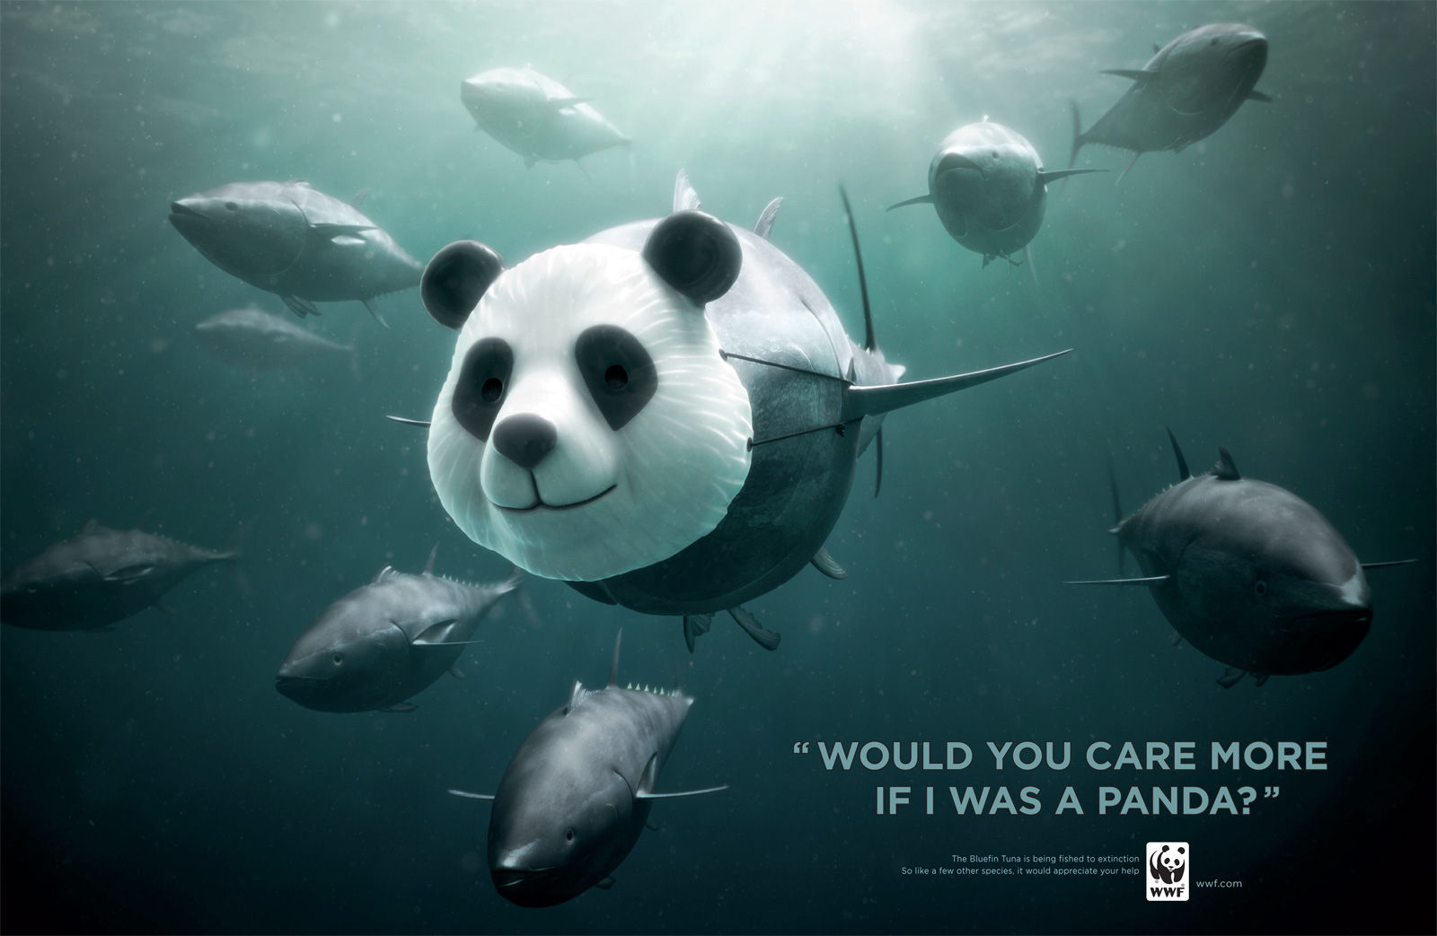
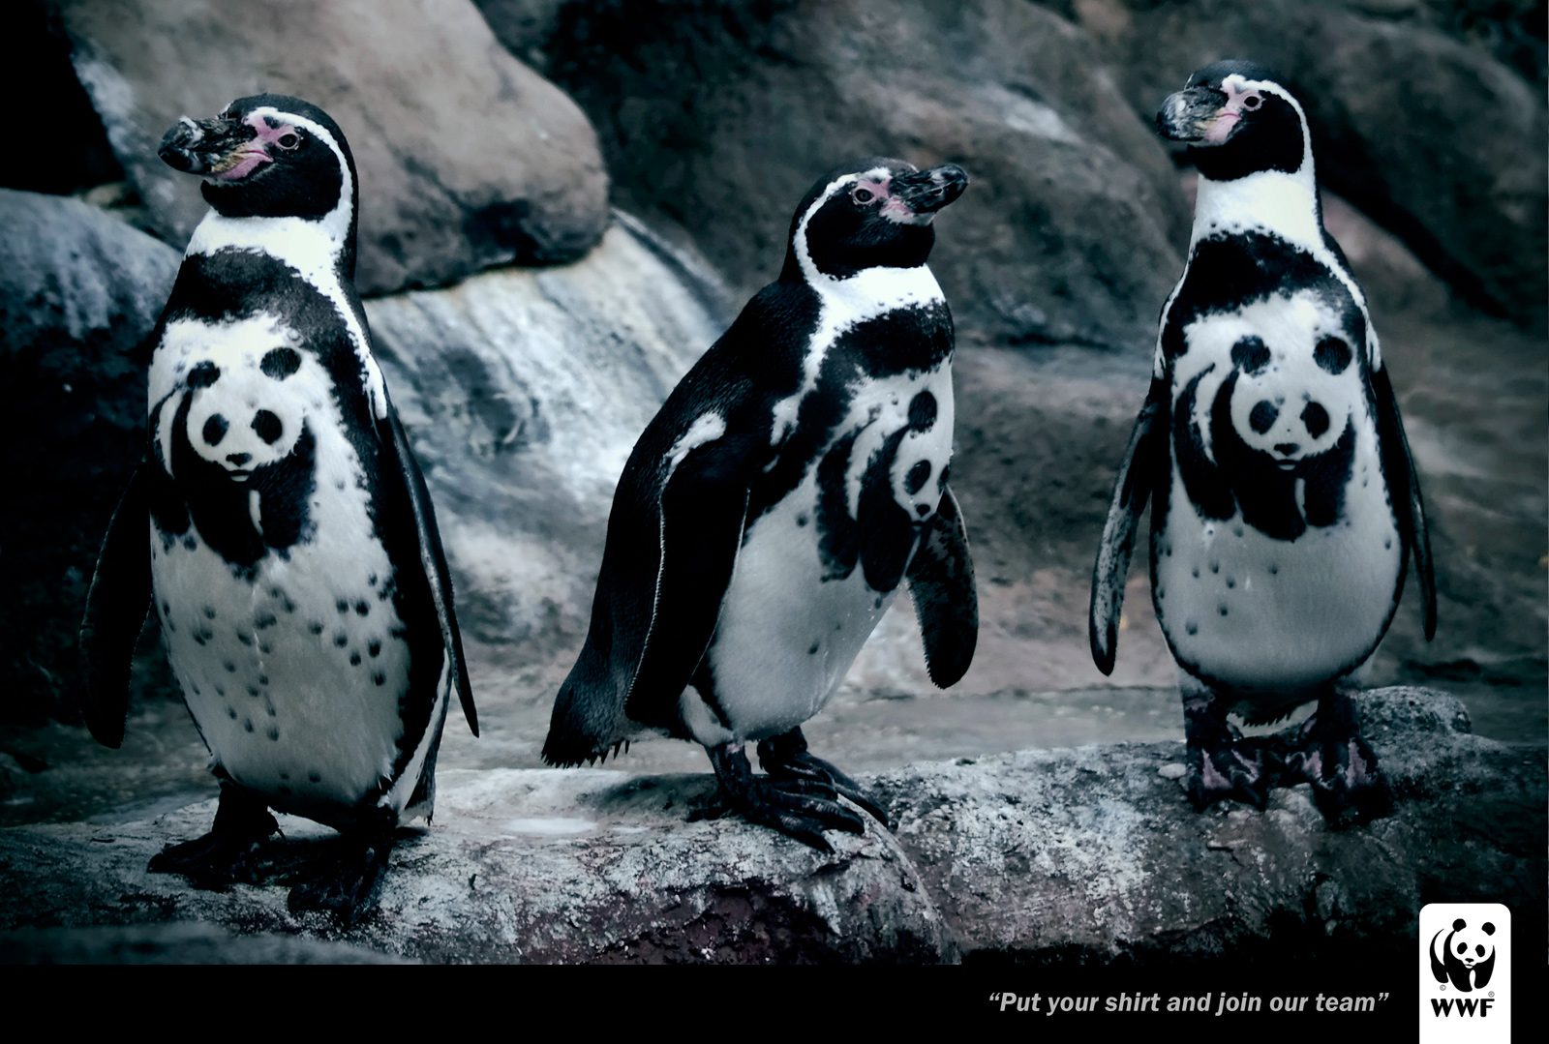
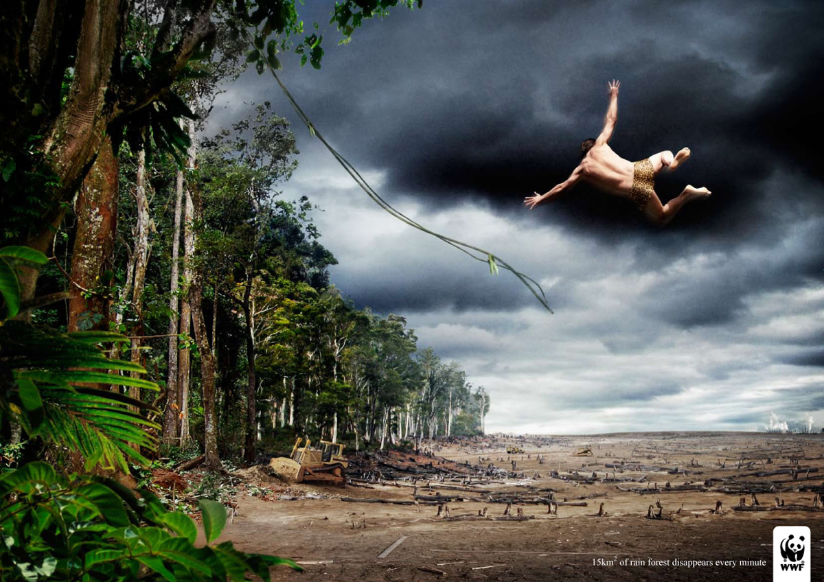
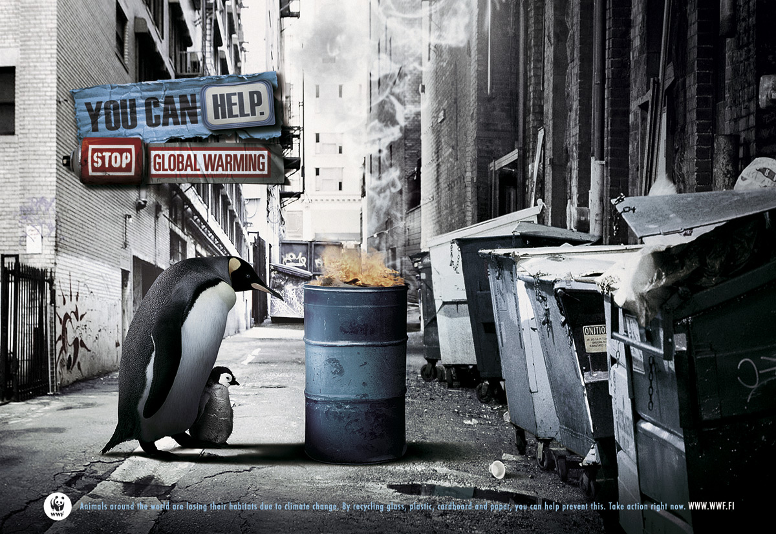
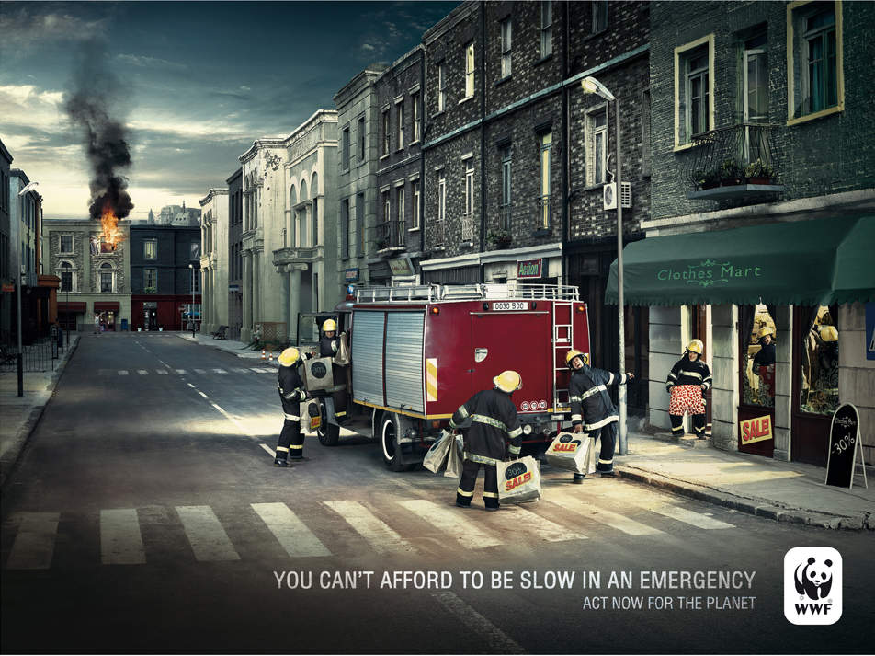
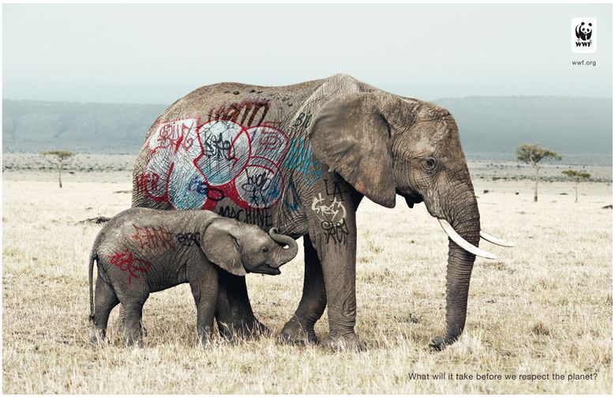
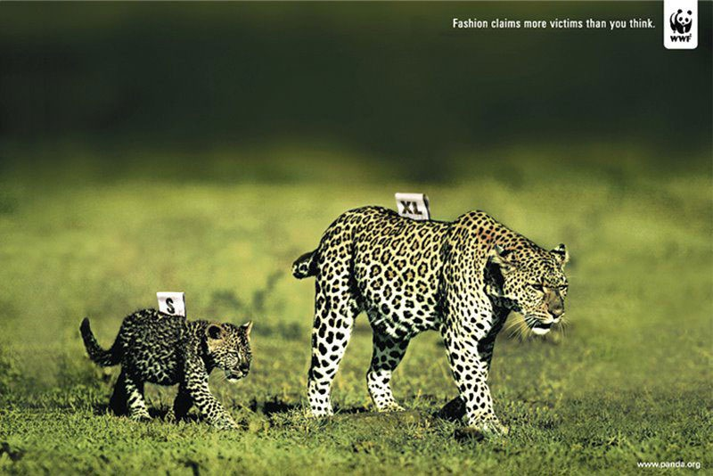
Obrázky:
http://www.ibelieveinadv.com/commons2/wwf-tunapanda.jpg
http://accel6.mettre-put-idata.over-blog.com/2/10/08/97/2009/Mai-2009/coupsdepub_WWF_Firemen.jpg
http://www.ads-ngo.com/2010/07/14/what-does-it-take-to-respect-the-planet-wwf/
http://www.ads-ngo.com/2012/08/08/put-your-shirt-and-join-our-team-wwf/
http://charlesdaoud.com/blog/wp-content/uploads/2008/09/wwfblood.jpg
http://designersday.blogspot.cz/2010/04/wwf-ads.html
http://help-our-planet.blogspot.cz/2011/07/white-tiger-and-wwf.html
http://sst2013-s307el.blogspot.cz/2013/05/visual-text-analysis-jasmine.html

