Seasons and Celebrations 2 – the Year Begins

New Year´s Eve is on December 31, the last day before the New Year begins. In many places, people go to parties or restaurants with friends in the evening. Sometimes they meet outside: in New York, thousands of people go to Times Square; in Sydney they go down near the sea; in London they go to Trafalgar Square. Just before midnight, people look at the clock, and together they count the last ten seconds before the New Year begins.
At midnight they stand in a circle, hold hands and sing an old song called Auld Lang Syne. A Scottish poet Robert Burns wrote the words of this song about 200 years ago. The song says that it is good to remember your old friends. Then many people drink a glass of champagne, light some fireworks, or dance until the sun comes up.
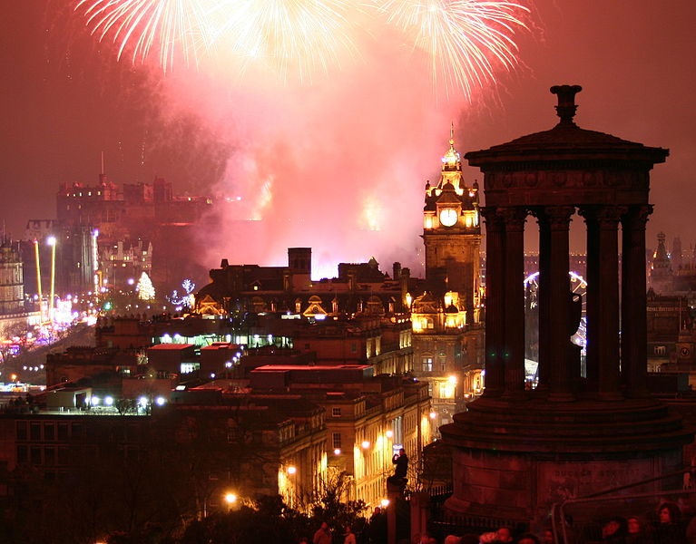In Scotland, New Year´s Eve has a special name: Hogmanay. At Hogmanay, there is a tradition called first-footing. The first person to come into the house in the New Year is the ´first footer´: if he is a tall man with dark hair, he will bring good luck to the house. He must carry some food, some money, or a piece of black coal for the fire. There are house and street parties with Scottish music, dancing, parades and lots of fireworks on Hogmanay in Scotland.
New Year´s Day, January 1, is a holiday for most people, and the banks and many shops do not open. A lot of people make a New Year´s resolution – that means they decide to do something different because they want to be a better person (e.g., ´I am going to stop smoking.´ or ´I am going to eat better.´ or ´I am going to learn something new.´)
The Chinese New Year is celebrated in January or February. It is the most important festival in the Chinese year. The festivities traditionally include firecrackers and dragon dances. Special foods such as dumplings and cakes are eaten. Red is a lucky colour for the New Year, and children are given lucky red envelopes filled with money.

Maguire, J.: Seasons and celebrations. OUP 2008.
Birdsall, M.: Festivals and Sopecial Days in Britain. Scholastic Ltd. 2007.
Figure from: http://en.wikipedia.org/wiki/File:EdinburghNYE.jpg; Robbie Shade, 1. 1. 2009.

Task 1: Work in pairs or groups of three and with your partner(s) brainstorm ideas about how you and your family celebrate New Year´s Eve. What you usually do, what you eat, whether you have any rituals (e.g. visiting friends, having parties, going to parties, inviting friends, etc.).
Doporučení: Udělejte před cvičením brainstorming v češtině a neznámé či nové výrazy zapište na tabuli, aby je děti měly k dispozici pro Task 1.

Task 2: Read the text and on a slip of paper take notes about:

- where people meet ´outside´ to celebrate New Year´s Eve (New York – Times Square, Sydney – at the see, London – Trafalgar Square)
- New Year´s Eve celebration in Scotland (cokoli z textu – Hogmanay, first-footing, parades, fireworks, Auld Lang Syne)
- Chinese New Year (January or February, firecrackers, dragon dances, dumplings and cakes, red colour, etc.)
In pairs talk about what you put down – exchange/share information.

Task 3: Give examples of some New Year´s resolutions. Have you ever made one? Were you successful? What was it about?
Podle modelu v textu I´m going to…
Děti nemusejí chtít sdílet svá předsevzetí, obzvláště nebyla-li úspěšná – raději práce ve dvojicích s kamarádem, případně tuto odpověď nevynucovat.

Task 4: With your teacher sing the Auld Lang Syne song:
Should auld acquaintance be forgot,
And never brought to mind?
Should auld acquaintance be forgot,
And auld lang syne?
CHORUS:
For auld lang syne, my dear,
for auld lang syne,
we’ll take a cup o’ kindness yet,
for auld lang syne.
Český překlad:
Může snad stará známost být zapomenuta,
aniž by někdy vytanula na mysli?
Může snad stará známost být zapomenuta,
byť to je už dávno?
REFRÉN:
Po dlouhé době, můj drahý,
po dlouhé době,
ještě si jednou připijeme na vlídnost,
a na tu dlouhou dobu.
http://cs.wikipedia.org/wiki/Auld_Lang_Syne

Melodie kdekoli na youtube.com.

