Shopping and Eating in London
You can buy nearly anything in London. Many of the most famous (and expensive) shops are in Regent Street, Bond Street, and in Knightsbridge. The most famous shop in the entire city – some people say the most famous in the world – is Harrods, in Knightsbridge. It began in 1849 when Henry Charles Harrod opened a small food shop in Brompton Road. The building in Knightsbridge opened in 1905, and now 4,000 people work there. Some people go there and buy something very, very small, just because they want the bag with the famous Harrods name on it.
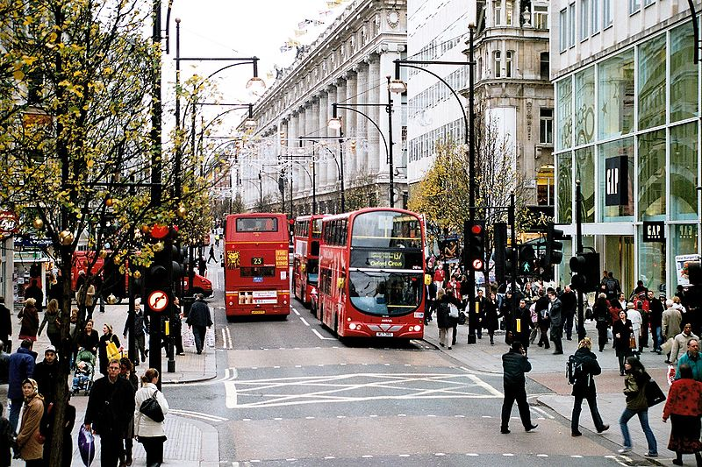Oxford Street has many big shops – Selfridges, Marks and Spencer, Debenhams. For smaller shops, go to Covent Garden. Charing Cross Road is famous for its bookshops. There are lots of them, and they sell old and new books.
At weekends you can visit some of London´s markets. Petticoat Lane market (open on Sundays) is in Middlesex Street, and has cheap clothes and things for the home. At the market in Portobello Road (open on Saturdays) you can buy old clocks, old chairs and tables, and hundreds of other things. At Brick Lane market (open on Sundays) in the East End, you can buy nearly everything. Old Spitalfields Market in Commercial Street (open on Sundays) has some of the latest clothes in town – and they´re cheap!
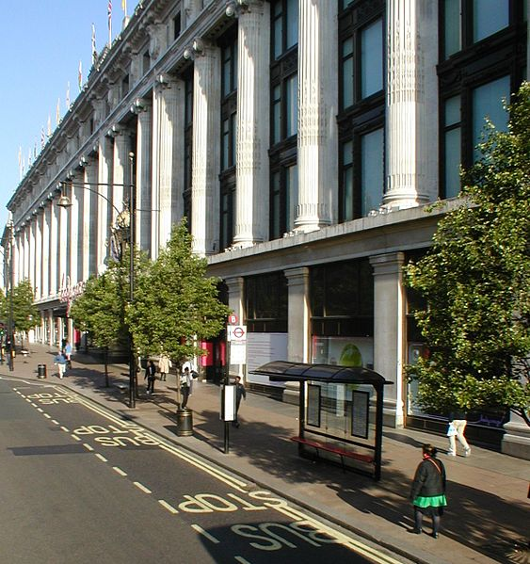When it is time for food, London has everything. You can have dinner in an expensive restaurant for hundreds of pounds – or you can buy a sandwich for not very much at all. You can eat in cafés or bars, you can buy food and take it away, and of course you can buy English fish and chips.
London has restaurants from nearly every country in the world, and not all of them are expensive. You can find food from Italy, Mexico, Spain, India, China, Russia, and many other countries. There are hundreds of good restaurants in Piccadilly, Soho, Leicester Square, and Covent Garden, and more in Kensington, Knightsbridge, and Chelsea.
For a very English afternoon, go to the Ritz in Piccadilly or the Savoy Hotel in the Strand for afternoon tea. You can listen to music, drink tea, and eat wonderful food. But remember to take a lot of money with you!
And do not forget about pubs. There are thousands of pubs in London. In many pubs you can eat and drink, and pub food is often cheap and good.
Escott, J.: London. OUP, 2008.
Figures from: http://en.wikipedia.org/wiki/File:Oxford_Street_December_2006.jpeg; Ysangkok, December 2006
http://en.wikipedia.org/wiki/File:Selfridges_Oxford_Street.jpg; Russ London, May 2003

Task 1: Read the first part of the text about shopping in London and according to it fill in the table below:

Place | Shops/Goods available
 | Harrods
Oxford Street
 | cheap clothes and things for the home
Portobello Road market
 | nearly everything
Old Spitalfields Market

Task 2: From the names of the countries mentioned in the text make appropriate adjectives/nationalities:

Country | Adjective/nationality
Italy
Mexico
Spain
India
China
Russia

Task 3: Work in pairs – to your partner give options for eating in London (according to the text).

Task 4: What do the following numbers from the text mean?

4,000 - thousands – 1849 - hundreds of pounds – 1905 - hundreds

