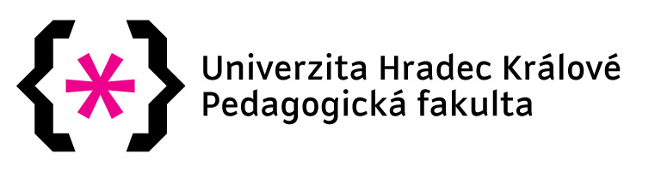

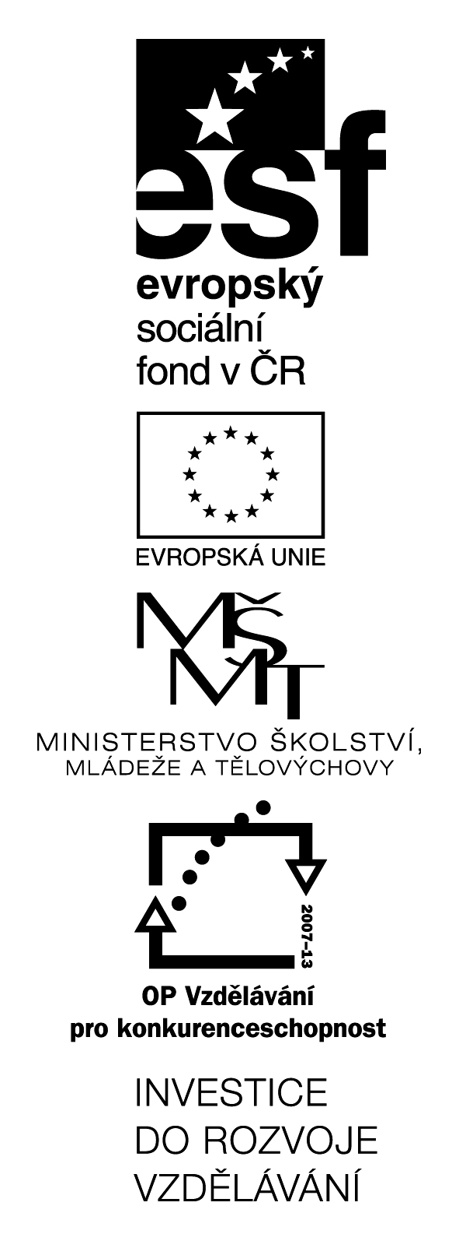
Gecko on the Wall (A1)
(reading material for young learners )

(KA2 – čtenářská gramotnost)

Projekt Littera
registrační číslo projektu CZ.1.07/1.1.00/14.0250
http://littera.uhk.cz

Littera

Zvýšení kvality jazykového vzdělávání v systému počátečního školství

Gecko on the wall
Daniele Brucket
- Speaking about geckos
  - Picture of gecko to motivate young learners.
  - We are speaking about geckos – (lizards, about 1500 different species, excellent night vision, autonomy – they can lose their tail)
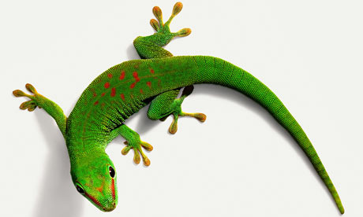

Questions: What colour is gecko?
How many eyes does he have?
How many legs, tails,…does he have?

Note: Activity – 5 minutes, Repetition: colours, numbers, parts of body

- Give the right picture to the right word and try to translate.
Gecko on the wall
Gecko on the rock
Gecko in the pool
Gecko on the roof
Gecko in the frock
Note: 5 minutes, kids work in groups, prepositions (on, in). If young learners don’t know prepositions, I write them on the black board.

- Listening
I read this short story to my learners. They listen and try to catch, what is the story about.
We are sitting in a circle and I ask them questions:
Who is the main character in this story?
Is it an animal?
Can we see him on the wall?
Can I see him on the table?
…
Note: 8 - 10 minutes

- Find a rhyme!
We are sitting in the circle. I read the story to children again. I read it slowly and they try to find all rhymes.

My wall – at all
Watching me – good company
…
Note: 3 minutes

- Complete the story
We are hanging the story on the cord. First goes a picture – then a part of story.
Now we have whole story in the classroom.
Note: 5 minutes, I am asking children: „ Is that rigth? Are you sure?“.

Complete: I say a part of a rhyme – story and kids complete a word.
E.g.: Teacher: „ There is a gecko on the rock,
She seems to be wearing a…“.
Kids: „frock“.
Note: 2 minutes

- Draw and colour
Kids have to draw their own gecko. Than a teacher says: „His/her body is green, yellow, brown…“.
„His/her eyes are blue“.
He/she has got red spots on his/her body“.
…
Note: 7-10 minutes, practising: colours

- A song
We are singing a song: Gecko on the wall,…
We are practising prepositions.
Note: 5 minutes, First children listen a song. Than, they repeat words after me. And we can sing togehter.
Zdroj: https://www.youtube.com/watch?v=T7AGChu_TPY

- Find some words
Note: 8 minutes. Kids try to find these words: in the text
Wall
Good
Gecko
Frock
Pool
Sunglasses

- Make your own short story about gecko
Kids are working in groups. They are drawing a picture about gecko.
When they are ready with the picture, they make a presentation of their stories – pantomime.
The others groups try to guess, what is the story about. If they are right, the group, which is doing the pantomime, shows the picture of their story – as a control.
Note: 30 minutes.

- Make your own book

We are making a small book about gecko. Pupils make it from the paper. They can use phrases from the story or they can make their own phrases.

Note: 30 minutes

Zdroje:
BRUCKERT, D. , Gecko on the wall. Amazon, 2010. ISBN 1452887802
http://www.theguardian.com/science/blog/2009/aug/05/gecko-grip-adhesion-gravity
http://www.bibliotastic.com/content/gecko-wall

Materiál neprošel jazykovou úpravou.
Autorka: Lucie Kynclová, studentka Učitelství pro 1. ročník základních škol, Modul AJ

