The Tortoise and the Ducks (A1)
(reading material for young learners )

(KA2 – čtenářská gramotnost)

Projekt Littera
registrační číslo projektu CZ.1.07/1.1.00/14.0250
http://littera.uhk.cz

Littera

Zvýšení kvality jazykového vzdělávání v systému počátečního školství

Aim: | comprehension
Class | 5th
Number of children: | all children
Time: | 3 lessons
Instruments: | this work sheet

THE TORTOISE AND THE DUCKS

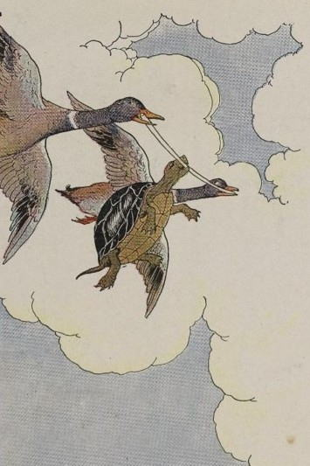
The Tortoise, you know, carries foolish his house on his back. No matter how hard he tries, he cannot leave home. They say that Jupiter punished him, because he was so lazy that he would not go to Jupiter's wedding, even he was especially invited.
After curiosity many years, Tortoise regretted that he did not go to that wedding. When he saw how gaily the birds flew and how the Hare and the Chipmunk and all the other animals ran nimbly, always see the beauty of nature, the Tortoise felt very sad and discontented. He wanted and to see the world too, and there he was with a house on his back and little short legs vanity which can not carry him far away.
One day he met a pair often of Ducks and told them all his trouble.
"We can help you to see the world," said the Ducks. "Bite into this stick with your teeth and we will carry you far up in the air where you can see the whole countryside. But do not say anything or you will regret it."
Of course the Tortoise was very happy. He bit into the stick strongly with his teeth, the two Ducks caught it at each end, and then they flew up toward the clouds.
At that moment a Crow flew by. He was very astonished when he saw them and cried:
"This must surely be lead to the King of Tortoises!"
"Certainly. Of course!" began the Tortoise.
But when he opened his mouth to say these foolish words he lost his hold on the stick, and fell down misfortune to the ground, where he broke into pieces on a rock.
Vocabulary:

no matter [nəu mætə:] – bez ohledu  especially [ispešli:] – zvláště, zejména  to regret [tu: rəgret] – litovat  gaily [geili:] – vesele  nimbly [nimbli:] – čile, hbitě | discontented [diskəntentid] – nespokojeně  carry [kæri:] – nést  toward [təwo:rd] – směrem k  astonished [əsta:ništ] – udivený

1) There are some extra words in the text. Find them, encircle and write them on the line.

2) Link the words with opposite meanings.
lazy
after
sad
far away
beauty
king
before
near
ugliness
queen
hard-working
happy

3) Fill in the crossword.

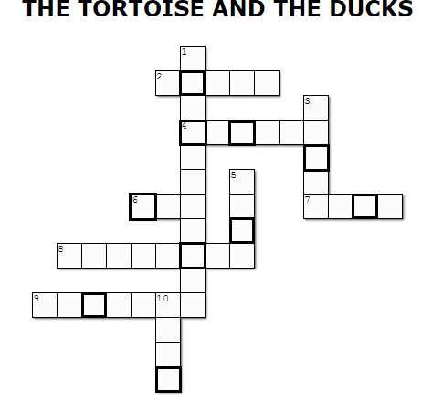
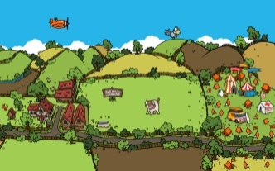
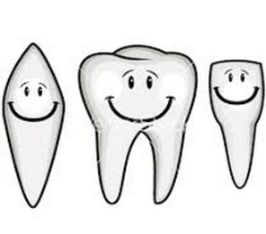
1. 2. 3.

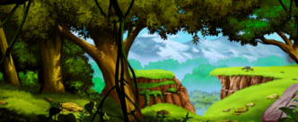
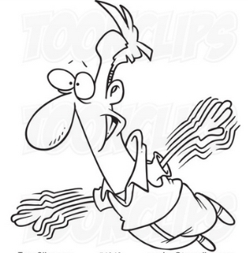
4. 5. 6.

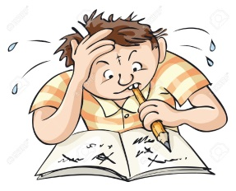
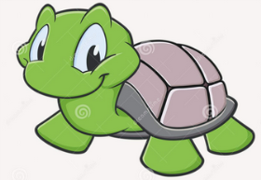
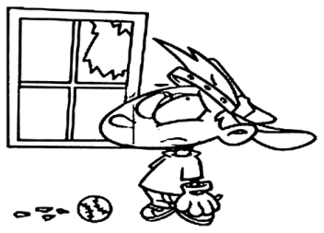
7. He is studying…….. 8. 9.

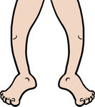
10.

Solution: ___________________________________________________________________________

4) Assign a number to each sentence.
Ducks helped him to see countryside.
Tortoise regretted that he did not go to the wedding
Crow was very astonished when he saw them.
Tortoise wanted to see the world.
Tortoise opened his mouth and lost his hold on the stick, and fell down to the ground.
Tortoise felt very sad and discontented when he saw other animals flying or running.

5) Draw the most favourite part of the story.

6) Word search – find words.
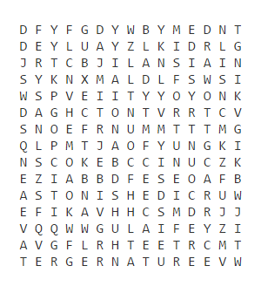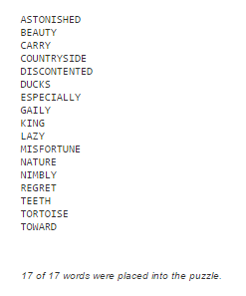
7) Debate about this story. What do you think about Tortoise? What is the point of this story, a lesson? Do you like this story? How do you feel about it?

Source:
Learn English with Fairy Stories. Copyright (C) 1999/2014 by Richard Graham www.GenkiEnglish.com. [online]. 19.1.2015 [cit. 2015-01-19]. Dostupné z:http://genkienglish.net/fairystories.htm

Teacher’s handout
Aim: | comprehension
Class | 5th
Number of children: | all children
Time: | 3 lessons
Instruments: | this work sheet

THE TORTOISE AND THE DUCKS

The Tortoise, you know, carries foolish his house on his back. No matter how hard he tries, he cannot leave home. They say that Jupiter punished him, because he was so lazy that he would not go to Jupiter's wedding, even he was especially invited.
After curiosity many years, Tortoise regretted that he did not go to that wedding. When he saw how gaily the birds flew and how the Hare and the Chipmunk and all the other animals ran nimbly, always see the beauty of nature, the Tortoise felt very sad and discontented. He wanted and to see the world too, and there he was with a house on his back and little short legs vanity which can not carry him far away.
One day he met a pair often of Ducks and told them all his trouble.
"We can help you to see the world," said the Ducks. "Bite into this stick with your teeth and we will carry you far up in the air where you can see the whole countryside. But do not say anything or you will regret it."
Of course the Tortoise was very happy. He bit into the stick strongly with his teeth, the two Ducks caught it at each end, and then they flew up toward the clouds.
At that moment a Crow flew by. He was very astonished when he saw them and cried:
"This must surely be lead to the King of Tortoises!"
"Certainly. Of course!" began the Tortoise.
But when he opened his mouth to say these foolish words he lost his hold on the stick, and fell down misfortune to the ground, where he broke into pieces on a rock.
Vocabulary:

no matter [nəu mætə:] – bez ohledu  especially [ispešli:] – zvláště, zejména  to regret [tu: rəgret] – litovat  gaily [geili:] – vesele  nimbly [nimbli:] – čile, hbitě | discontented [diskəntentid] – nespokojeně  carry [kæri:] – nést  toward [təwo:rd] – směrem k  astonished [əsta:ništ] – udivený

1) There are some extra words in the text. Find them, encircle and write them on the line.

2) Link the words with the opposite meaning.
lazy
after
sad
far away
beauty
king
before
near
ugliness
queen
hard-working
happy

3) Fill in the crossword.
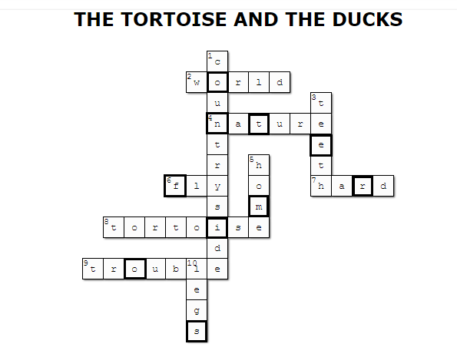
1. 2. 3.

4. 5. 6.

7. He is studying…….. 8. 9.

10.

Solution:____________________________________________________________________

4) Assign a number to each sentence.
Ducks helped him to see countryside. | 4.
Tortoise regretted that he did not go to the wedding | 1.
Crow was very astonished when he saw them. | 5.
Tortoise wanted to see the world. | 3.
Tortoise opened his mouth and lost his hold on the stick, and fell down to the ground. | 6.
Tortoise felt very sad and discontented when he saw other animals flying or running. | 2.

5) Draw the most favourite part of the story.

6) Word search – find words.
7) Debate about this story. What do you think about Tortoise? What is the point of this story, a lesson? Do you like this story? How do you feel about it?

Source:
Learn English with Fairy Stories. Copyright (C) 1999/2014 by Richard Graham www.GenkiEnglish.com. [online]. 19.1.2015 [cit. 2015-01-19]. Dostupné z:http://genkienglish.net/fairystories.htm

Materiál neprošel jazykovou úpravou.
Autorka: Sajnzaja Bajarová, studentka Učitelství pro 1. ročník základních škol, Modul AJ

