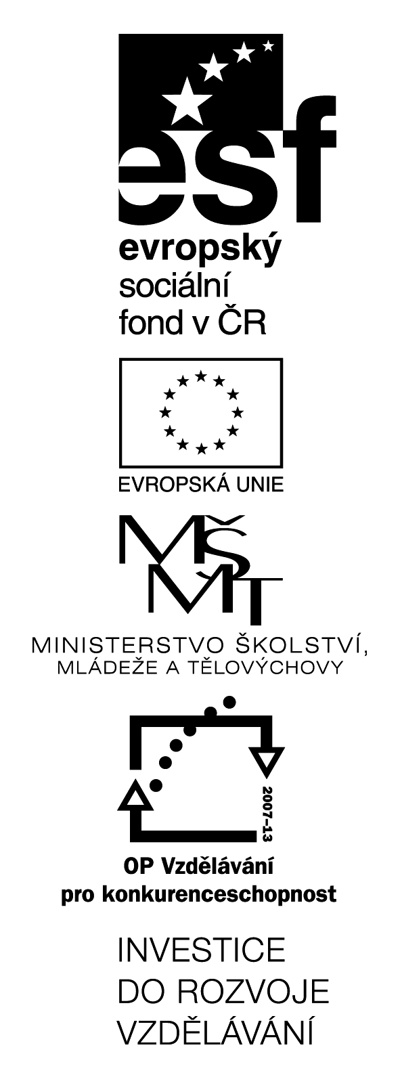
Studentský materiál A1

(KA4 – metoda CLIL)

Projekt Littera
registrační číslo projektu CZ.1.07/1.1.00/14.0250
http://littera.uhk.cz

Littera

Zvýšení kvality jazykového vzdělávání v systému počátečního školství

CLIL LESSON

Název školy: | Datum:
Školní rok: | Třída: 4.
Třídní učitelka:
NATURE
Living nature – plants, mushrooms and animals/humans.
AIMS
- Get new knowledge about living nature (mainly about butterflies life cycle)
- Pupil are able to devide living nature into 3 groups.
- Pupil get new vocabulary about nature – plants and animal.

VLASTNÍ PŘÍPRAVA
Časová orientace | Struktura a metodické postupy | Poznámky a pomůcky
2min  8min  6min  5min  15min  6min  3min | GREETING AND AIMS OF THE LESSON  Teacher greets children and tell them aims of the lesson.  We will get new vocabulary about nature.  We will speak about living nature – mainly abou animals and plants.  MOTIVATION – POEM  Everybody get paper with poem a read it – if pupils find new, unknown word – they will write it on the blackboard. If somebody know some word from the blackboard – he or she could translate it and write it there.  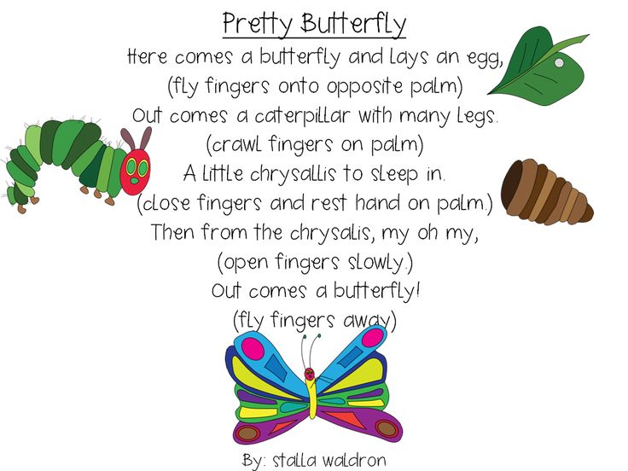  DISCUSSION (about living nature).  We can devided living nature into 3 groups - plants, mushrooms and animals/humans.  - Which plants do you know? (children say examples)  Q: Where we can find plants? (In the garden, in park, in forest).  - Which mushrooms do you know? (champignon)  Q: Do you like mushoroom hunting?  - Which animlas do you know?  Q: In which group we can find butterfly from our poem?  GAME- LIVING NATURE  Rules:  When pupils see on the pictuce for example cat – the have to make a special move.  Teacher shows pupils picture, word or both of it,  - Animals/human – jump  - Plants – stand and raise their hands (like a tree)  - Mushrooms- sit and join hands above their head (like a mushroom)  Example:  To which group belong this? And children have to move accroding to the rules.  ROSE  VIDEO (Life cycle of butterfly) + WORKSHEET  - Pupils watch the video and write down words, which they know (with translation).  - Pupils count the words and one, who win, will read it.  - Pupils get worksheet and watch the video again.  - Checking worksheets.  https://www.youtube.com/watch?v=O1S8WzwLPlM  REVISION – NEW VOCABULARY  There are some words in english on the blackboard. Teacher open it and pupils write them into their notebooks. If somebody know some word from the blackboard – he or she could write there translation.  LAYS AN EGG – klade vejce  CHRYSALIS – kukla motýla  PUPA – kukla  CHAMPIGNON – žampión  CATEPILLAR – housenka  ADULT- dospělý  NATURE- příroda  CONCLUSION  Did you learned something new?  Were you surprised by anything?  