Metodický list
Famous Americans
(KA4)

Littera

Zvýšení kvality jazykového vzdělávání v systému počátečního školství

Tento materiál vznikl v rámci předmětu Reálie anglicky mluvících zemí 2.
Autor: Kateřina Pultarová
Text neprošel jazykovou revizí.

- Which famous Americans do you know and what can you tell us about them?

- Match pictures to the names and jobs
Katy Perry Serena Williams Tom Hanks Abraham Lincoln Ernest Hemingway

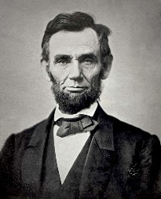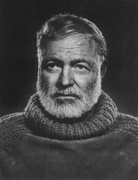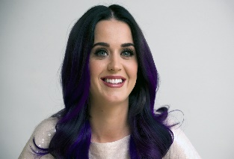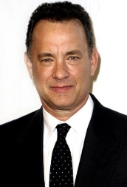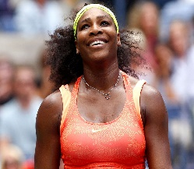

singer president sportswoman writer actor

- Correct the mistakes.

- George Washington was the first American writer.
b) Johnny Depp starred in Titanic.
c) J. K. Rowling, who wrote Harry Potter, is American.
d) God Save the Queen is the name of the American anthem.
e) Barack Obama is the American president now.

- Information gap

Student A | BORN | DIED | JOB | INTERESTING FACT
Angelina Jolie | 1975 | X | actress
Madonna |  | X |  | Referred to as the "Queen of Pop"
Benjamin Franklin |  | 1790 | politician
John Steinbeck | 1902 |  |  | The winner of the Nobel Prize
Steve Jobs |  | 2011 | businessman

Student B | BORN | DIED | JOB | INTERESTING FACT
Angelina Jolie |  | X |  | 3 children + 3 adopted children from Asia and Africa
Madonna | 1958 | X | singer
Benjamin Franklin | 1706 |  |  | His head is on the $100 bill
John Steinbeck |  | 1968 | writer
Steve Jobs | 1955 |  |  | The co-founder of Apple

- Dialogue making

Choose a person from Exercise 3 and in pairs make interview with that person using the following questions. Switch the roles.
- What was your childhood like?
- Have you ever wanted to do this job?
- What are the positives of being a famous person?
- What do you like doing in your free time?

- American Idol
Choose a famous American that you admire and talk about him/her in pairs.

