Poznámky a klíč
Famous Americans
(KA4)

Littera

Zvýšení kvality jazykového vzdělávání v systému počátečního školství

Tento materiál vznikl v rámci předmětu Reálie anglicky mluvících zemí 2.
Autor: Kateřina Pultarová
Text neprošel jazykovou revizí.

- WARM UP: Brainstorming

Which famous Americans do you know and what can you tell us about them?

Students’ answers. Try to group the names according to professions.

- Match pictures to the names and jobs
Katy Perry Serena Williams Tom Hanks Abraham Lincoln Ernest Hemingway

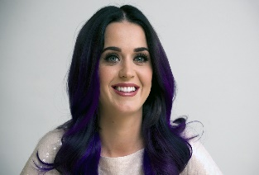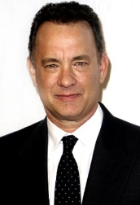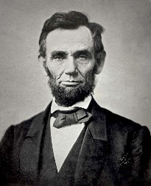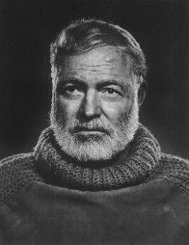

Singer sportswoman actor president writer

- Correct the mistakes.

- George Washington was the first American writer. president
b) Johnny Depp starred in Titanic. Leonardo DiCaprio
c) J. K. Rowling, who wrote Harry Potter, is American. British
d) God Save the Queen is the name of the American anthem. The Star-Spangled Banner
e) Barack Obama is the American president now. Donald Trump

- Information gap
Students make pairs. Give each member of the pair one card and encourage them to ask questions to fill in the missing information.

Student A | BORN | DIED | JOB | INTERESTING FACT
Angelina Jolie | 1975 | X | actress | 3 children + 3 adopted children from Asia and Africa
Madonna | 1958 | X | singer | Referred to as the "Queen of Pop"
Benjamin Franklin | 1706 | 1790 | politician | His head is on the $100 bill
John Steinbeck | 1902 | 1968 | writer | The winner of the Nobel Prize
Steve Jobs | 1955 | 2011 | businessman | The co-founder of Apple

Student B | BORN | DIED | JOB | INTERESTING FACT
Angelina Jolie | 1975 | X | actress | 3 children + 3 adopted children from Asia and Africa
Madonna | 1958 | X | singer | Referred to as the "Queen of Pop"
Benjamin Franklin | 1706 | 1790 | politician | His head is on the $100 bill
John Steinbeck | 1902 | 1968 | writer | The winner of the Nobel Prize
Steve Jobs | 1955 | 2011 | businessman | The co-founder of Apple

- Dialogue making

Choose a person from Exercise 3 and in pairs make interview with that person using the following questions. Switch the roles.
- What was your childhood like?
- Have you ever wanted to do this job?
- What are the positives of being a famous person?
- What do you like doing in your free time?
Students’ answers. Encourage the students to come up with their own questions.
- American Idol
Choose a famous American that you admire and talk about him/her in pairs.
Students’ answers

