Poznámky a klíč
The USA - FLAG
(KA2)

Littera

Zvýšení kvality jazykového vzdělávání v systému počátečního školství

Tento materiál vznikl v rámci předmětu Reálie anglicky mluvících zemí 2.
Autor: Veronika Tomšová
Text neprošel jazykovou revizí.

- Colour in the flag of the USA
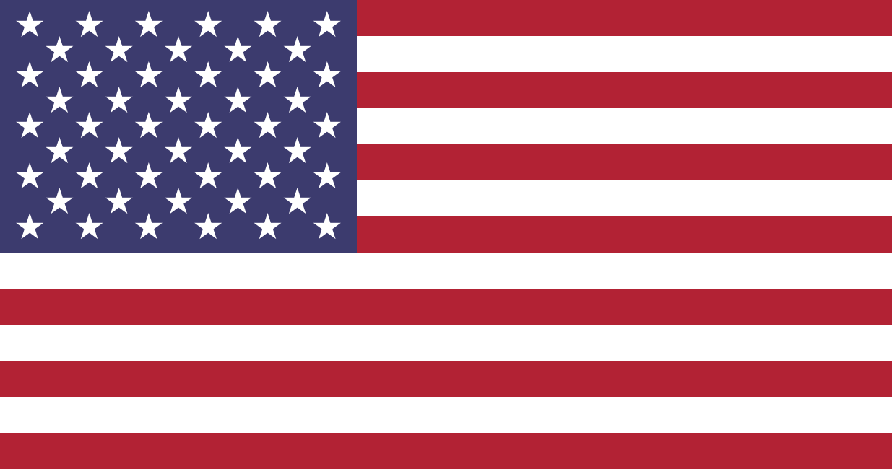

- Answer the questions below.
- How many stars are there on the flag of the USA?
- Do you know what the stars represent?
- How many stripes are there on the flag of the USA?
- Do you know what the stripes on the flag of the USA represent??
- Do you know some nicknames for the flag of the USA? (name at least 2)
- What, in your opinion, do the colours on the flag of the USA represent? What kind of qualities?
- What does the flag of the USA represent?

- There are 50 stars on the flag of the USA.
- The stars represent the 50 states of the USA.
- There are 13 stripes.
- They represent 13 British colonies that declared independence from the Kingdom of Great Britain, and became the first states in the U.S.
- The American flag, The stars and Stripes, Old Glory, The white and blue, The Star-Spangled Banner
- Red – bravery and strength
Blue – watchfulness, perseverance and justice
White – purity and innocence
- The flag of the USA represents the freedom of the USA.

- Read the text below and check your answers with the previous exercise.
The flag of the United States of America is a national flag. It represents the freedom of the United States.
The flag of the United States has 7 red stripes and 6 white stripes. These 13 stripes stand for the original thirteen colonies. The flag also has a blue canton, a rectangle in the top left corner. The canton has one white star for every state.
When a new state joins the United States a new flag is made with an extra star. The new flag is first flown on the "4th of July", Independence Day.
The colors in the flag are red, white and blue. The colors have no special meaning in the flag, but in the coat of arms white stands for purity and innocence, red for bravery and strength and blue for watchfulness, perseverance and justice.
The flag is also often called the Stars and Stripes, the Star-Spangled Banner, or Old Glory. The national anthem of the United States both reference the flag.
(The text adapted from: https://simple.wikipedia.org/wiki/Flag_of_the_United_States)
- Circle the correct answer

- Choose a word to replace “original” in the text
a) elementary
b) proximate
c) primary
- Choose a word to replace “joins” in the text
a) appends
b) enjoy
c) strike in
- Choose a word to replace “called” in the text
a) canceled
b) named
c) calling

- Read the text below and complete it with the right words from the box.

NATIONAL FLAG DAY
On June 14 we honour Old Glory on National Flag Day. This day commemorates the adoption of the United States flag on June 14, 1777.
On National Flag Day, Americans show respect for the U.S. Flag and what it represents. Representing independence and unity, the Stars and Stripes have become a powerful symbol of Americanism and is flown proudly.
While Betsy Ross has been given credit for stitching together the first American flag, there isn’t any sound evidence supporting the story. At the same time, there is any to disprove it, either. During Ross’s Revolutionary time, several standards were carried bearing red and white stripes and varying symbols where the blue field and stars now reside. Since 1777, the design of the flag has been officially modified 26 times. For 47 years, the 48-star flag was in effect. In 1959, the 49-star version became official on July 4. President Eisenhower ordered the 50-star flag on August 21, 1959.
Seventeen-year-old Robert G. Heft of Ohio designed the 50-star American flag. His was one of the more than 1,500 designs that were submitted to President Dwight D. Eisenhower.
(The text adapted from: https://www.nationaldaycalendar.com/days-2/national-flag-day-june-14/)
- Based on the previous text answer the following questions.
- When is National Flag Day celebrated?
- Who has been given credit for the first American flag?
- How many times has the flag been officially modified?
- When was the 50-star flag ordered and by whom?
- Who designed the 50-star American flag?

- on the June 14
- Betsy Ross
- 26 times
- on August 21, 1959 by President Dwight D. Eisenhower
- 17-year old Robert G. Heft from Ohio

