Metodický list
Traditional American Food
(KA2)

Littera

Zvýšení kvality jazykového vzdělávání v systému počátečního školství

Tento materiál vznikl v rámci předmětu Reálie anglicky mluvících zemí 2.
Autor: Brůnová Kateřina
Text neprošel jazykovou revizí.

Traditional American Food

1) Hot dogs
While Germans and Austrians disagree about who first ¹_________ the hot dog, mentions of sausages date back to Roman times, though it was German “dachshund” sausages that first caught the attention of the American public. The sausages were wildly popular at the 1893 Columbian Exposition in Chicago, where many say the invention of the hot dog bun occurred.

2) Apple pie
Perhaps the most iconic item on any all-American menu, apple pie first came to the U.S. by way of British, Swedish, and Dutch immigrants, where it was a staple of colonial diets for more than a century thanks to its cheap preparation. During World War II, apple pie ²_________ inextricably linked to American culture, and has since become a fixture of Americana.

3) Macaroni and cheese
The mouthwatering combination of pasta and cheese predates the founding of America by several hundred years, but Thomas Jefferson is widely credited with introducing the much-loved dish into American cuisine. After a trip through Italy, Jefferson brought a pasta maker and Parmesan cheese back to Virginia and famously ³_________ the dish at a state dinner in 1802.
4) Buffalo chicken wings
One version of the story says Teressa Bellissimo came up with the Buffalo wing as a way to make use of an accidental shipment of chicken wings; another ⁴_________ that it was a late-night snack prepared on the spot to satiate her son and his drinking buddies. Regardless, the origin of the Buffalo wing is little disputed, and was first served in 1964 at the Anchor Bar in—where else—Buffalo, New York.

5) The hamburger
Though the name “hamburger” and the ingredients have strong German roots, the burger as we know it today was likely ⁵_________ in New York, when German immigrants combined the famous “Hamburg steak” from their homeland with two slices of bread. The burger’s popularity at Philadelphia’s 1876 Centennial Exposition, the first official World's Fair in the U.S., soon made it a household name.

6) Barbecue ribs
Barbecuing is as old as this country—George Washington even made reference to a barbecue in Virginia in 1769. Whether you’re partial to Memphis’s wet ribs, Kansas City’s hearty barbecue sauce, or the Carolinas’ pork-only menus, barbecue in America has ⁶_________ from a basic form of cooking into a highly specialized, regional art.
(Chase, 2017)
Tasks:
- Connect the articles with pictures:

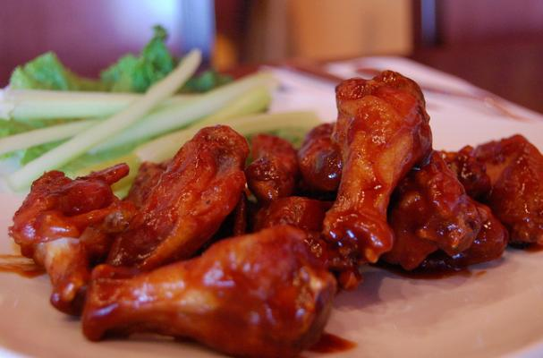

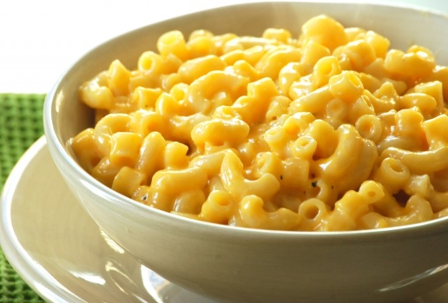

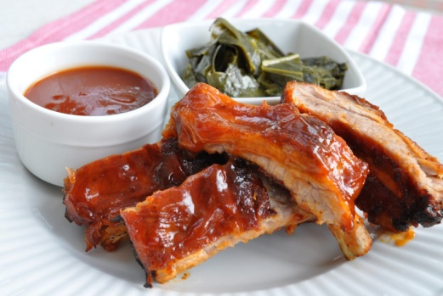

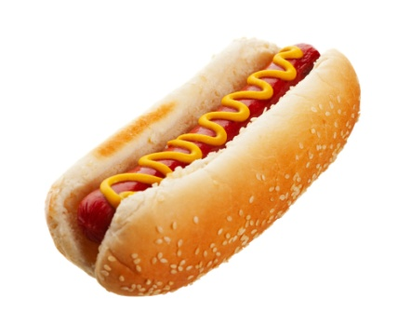

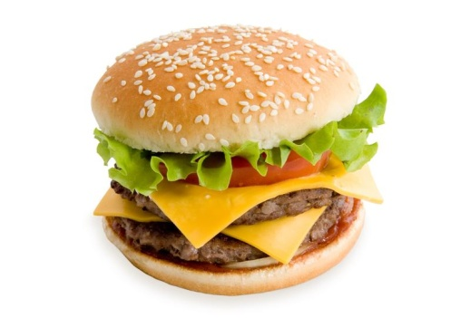

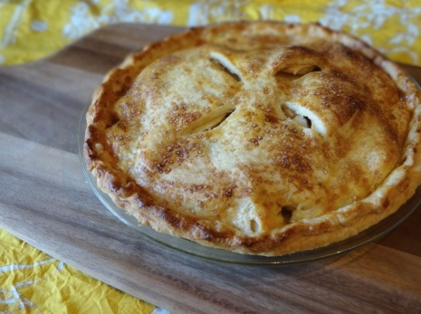

- Multiple choice – choose the best option:

1. a) ate b) invented c) find

2. a) became b) happened c) turned

3. a) served b) eaten c) show

4. a) claimed b) said c) says

5. a) invent b) born c) eat

6. a) involved b) progress c) evolved

- Write right questions based on information provided in the text:
      - ………………………………………………………………………………………………?
At the 1893 Columbian Exposition in Chicago

      - ………………………………………………………………………………………………?
During World War II

      - ………………………………………………………………………………………………?
Thomas Jefferson

      - ………………………………………………………………………………………………?
At the Anchor Bar in Buffalo, New York

      - ………………………………………………………………………………………………?
German immigrants

      - ………………………………………………………………………………………………?
In 1769

- True or false (tick true/cross false):

Hot dog bun was probably invented at the 1893 Columbian Exposition in Chicago

Apple pie became iconic for America after World War II.

Thomas Jefferson introduced macaroni and cheese to America in the 18th century.

Buffalo chicken wings were first made by Teressa Bellissimo’s son.

German immigrants brought the nowadays hamburger from Germany.

- Put the paragraphs in the correct order:

Buffalo wings

  - Preheat the oven to 425 degrees F.

  - While the chicken is roasting, melt the butter in a small bowl along with the garlic. Pour this along with hot sauce and salt into a bowl large enough to hold all of the chicken and stir to combine.

  - Remove the tips of the wings and discard or save for making stock. Using kitchen shears, or a knife, separate the wings at the joint. Place the wings into the steamer basket, cover, reduce the heat to medium and steam for 10 minutes. Remove the wings from the basket and carefully pat dry. Lay the wings out on a cooling rack set in a half sheet pan lined with paper towels and place in the refrigerator for 1 hour.

  - Replace the paper towels with parchment paper. Roast on the middle rack of the oven for 20 minutes. Turn the wings over and cook another 20 minutes or until meat is cooked through and the skin is golden brown.

  - Remove the wings from the oven and transfer to the bowl and toss with the sauce. Serve warm.

  - Place a 6-quart saucepan with a steamer basket and 1-inch of water in the bottom, over high heat, cover and bring to a boil.

(Recipe courtesy of Alton Brown, 2007)

1 ___ 2___ 3___ 4___ 5___ 6___

- Word search: Locate the given words, running in one of eight possible directions horizontally, vertically, or diagonally.

FOOD
APPLE
BARBECUE
CHEESE
CHICKEN
HAMBURGER
MACARONI
PIE
RIBS
SAUSAGE
WINGS

- What is a traditional food in your country?

……………………………………………………………………………………………………….

CHASE, Abbey. (2017) “10 Traditional American Foods—And Where to Eat Them”. Condé Nast Traveller. [online]. [16 May 2017]. http://www.cntraveler.com/gallery/traditional-american-foods-and-where-to-eat-them
BROWN, Alton. (2007) “Buffalo Wings Recipe” Food Network [online]. Copyright © 2017. [16 May 2017]. http://www.foodnetwork.com/recipes/alton-brown/buffalo-wings-recipe

