Metodický list
USA - Education
(KA2)

Littera

Zvýšení kvality jazykového vzdělávání v systému počátečního školství

Tento materiál vznikl v rámci předmětu Reálie anglicky mluvících zemí 2.
Autor: Veronika Sokolářová
Text neprošel jazykovou revizí.

- Carefully read the text and complete the following tasks.

One of the most attractive features of the U.S. higher education system is the flexibility it provides through the number and diversity of institution types it encompasses.

This diversity offers students options to specialize in a variety of academic disciplines and even gain employment training.

More than 4,500 accredited institutions make up U.S. higher education in the United States. Unlike many countries, U.S. higher education institutions are not centrally (organize) …………………. or (manage) ……………………., but are accredited on a national or regional level by independent accrediting bodies.

A variety of institution types offer higher-education degrees. Liberal arts institutions, for example, offer courses in the arts, humanities, languages, and social and physical sciences. The ……………….¹ of liberal arts institutions are private. Private colleges and universities are funded by a combination of endowments, gifts from alumni, research grants, and tuition fees. Private colleges and universities are usually (small) ………………… than public institutions and can have a religious affiliation or be single-sex schools.

Community colleges are …………….² option and provide two-year associate degree programs to prepare students to continue studies for an undergraduate degree or help them gain occupational skills for immediate employment. State colleges and universities, also called "public universities," were (find)…………….….. and subsidized by U.S. state governments to provide a low-cost education to residents of that state. Public universities generally offer access to research opportunities and classes in a wide variety of fields of study. These universities tend to be very large and generally admit a wider range of students than private universities. Each student's interests will guide his/her choice among the many possibilities.

Regardless of the institution type, in the United States, students typically earn credits for courses they take and these credits count towards the completion of a program. Courses are often divided into "core" subject areas to provide the foundation of the degree program and "major" courses to provide specialization in a subject area. Students can also take "elective" courses to explore other topics of interest for a well-rounded educational experience.

The U.S. academic calendar typically (run) ……………… from September to May and can be divided into two academic terms of 16-18 weeks known as semesters. Alternatively, some schools may operate on a quarter or trimester system of multiple terms of 10-12 weeks.

With the variety of available U.S. higher education options, students are sure to find the right fit for their academic, financial, and personal needs.
(Text převzat ze stránky: https://educationusa.state.gov/experience-studying-usa/us-educational-system )
- Answer the questions.
- How many accredited institutions are there in the USA?
- How are the private colleges and universities funded?
- What are the state colleges and universities called?
- How are the courses divided?
- How can the U.S. academic calendar be divided?

………………………………………………………………………………………………………………………………………………………………………………………………………………………………………………………………………………………………………………………………………………………………………………………………………………………………………………………………………………………………………………………………………………………………………………………………………………………………………………………………………………………………………………………………………………………………………………………………………………………
- Circle the correct answer.
- Choose a word that fits the best in the blank spot.
a) majority
b) most
c) major
- Choose a word that fits the best in the blank spot.
a) others
b) further
c) another
- Write the correct form of words in brackets.

- Circle the correct answer.

- Choose a word to replace “wide” in the text.
a) broad
b) obvious
c) clear
- Choose a word to replace “provide” in the text.
a) state
b) present
c) give
- Choose a word to replace “sure” in the text.
a) surely
b) guaranteed
c) secure

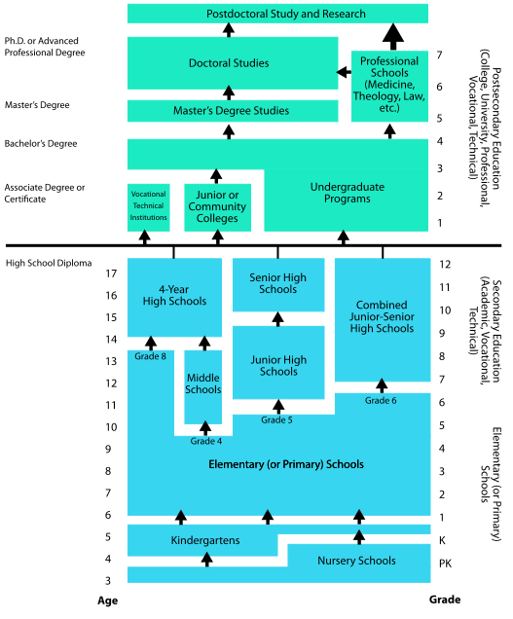
- Go through the table below and discuss with your partner what you would be studying right now if you were living in the USA.

