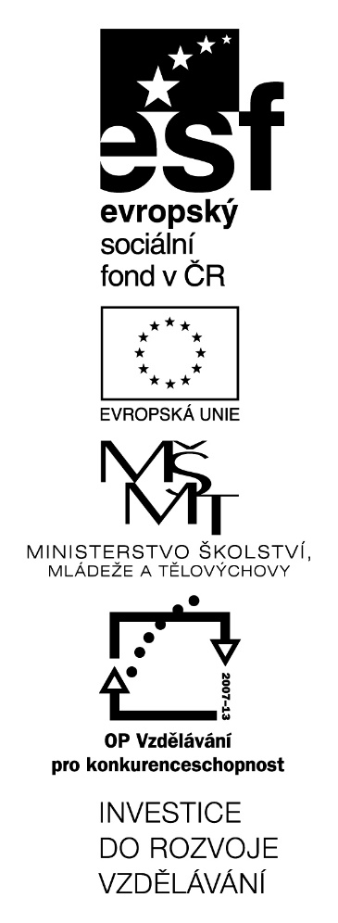
Musical Instruments

(KA4)

Littera

Zvýšení kvality jazykového vzdělávání v systému počátečního školství

Tento materiál vznikl v rámci předmětu Metodika anglického jazyka 3
Autor: Jana Eibová
Text neprošel jazykovou revizí.

Subject: Music
Class: 5.
Topic: Musical instruments
Aims of the lesson: Pupils know how to say some of musical instruments in English

Time | Aktivity | Other
5 minutes | Pictures of musical instruments  - On the board  - Teacher says the word and pupils repeat  - Pupils say the words themselves – all of them  - Pupils say the words one by one | Using pictures from worksheet
5 min | Simon says  - Eg. „Simon says, play the flute“  - At first, teacher is Simon, then pupils are | Phrase „play the ____“
10 min | Listening  - Teacher plays some music – just musical instruments and pupils try to recognize them  - They write down as many as possible – even the ones they know from English lessons or life  - What is the mood of the song? How did you feel? | Eg.  FILMHARMONIE – How to train your dragon (on youtube) they may know the theme, so it would be easier for them
10 min | Singing  - English song I am the music man  - https://www.youtube.com/watch?v=22kqia2ibVU  - Teacher doesn’t play the video for children, but plays the piano!! (D dur – easy to learn song)  - At first, they sing it part by part, then the whole song
10 min | Dancing  - Moves which are repeated in every part of the song  - They show what they sing (eg. Play the piano – moves with their hands like they are playing)
5 min | Revision  - Scrambled words – worksheet  - Pictures to be coloured – stick them into their notebooks

SCRAMBLED WORDS

Find the musical instrument and match it with the picture.
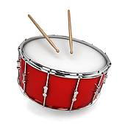
NIOLIV
_____________
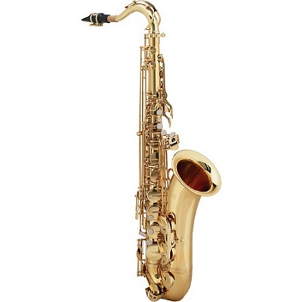
TEPMRUT
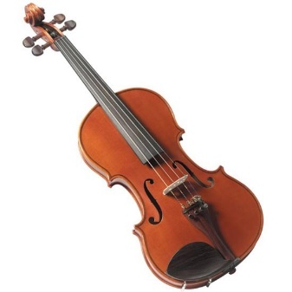
_____________
IAPON
_____________
TUEFL
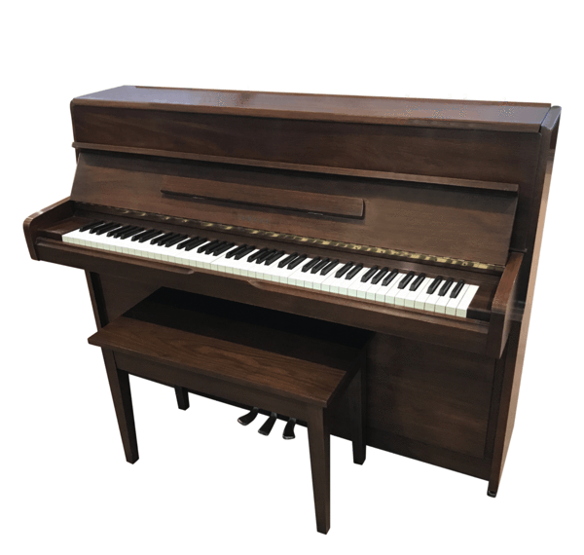
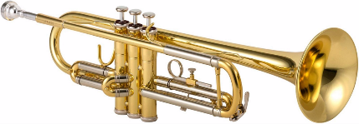
_____________
MUDR
_____________
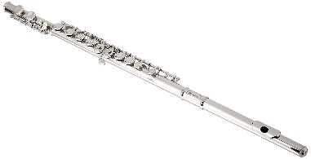
HONEXOPAS
_____________

Colour pictures and stick them into you vocabulary notebook.
