The Solar System
(KA4)

Littera

Zvýšení kvality jazykového vzdělávání v systému počátečního školství

Tento materiál vznikl v rámci předmětu Metodika anglického jazyka 3
Autor: Vendula Koutská
Text neprošel jazykovou revizí.

CLIL LESSON
Topic: SOLAR SYSTEM
Class: 5.
Time: 45 minutes
Materials: pictures for motivation, worksheet about solar system, worksheet with song, computer, conversation cards
Aims:
- Pupil is part of the conservation.
- Pupil makes the grammatically right sentence.
- Pupil reads the text with understanding. Find the information in text and give an answer.
- Pupil’s using dictionary for translation unknown words.
- Pupil’s work in groups.
- Pupil gets some new vocabulary from area of solar system.

Time | Activities | Notes
2 min  6 min  10 min  12 min  8 min  7 min | Greeting and telling about the aims of the lesson.  - speak about space (universe, planets)  - get new vocabulary about our solar system, planets  Motivation with pictures projected on the board  - teacher show two pictures of astronaut and the Earth  - children look at the picture and thinking about it for a short time  - teacher ask the children  - What you see in the picture?  - Imagine you are astronaut. How do you feel at the moment?  - Do you know something about universe?  - the child that has the ball speak  - if the pupil doesn’t know some word – find it in dictionary  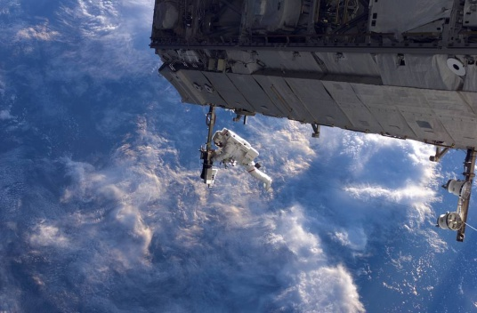  Picture 1.  Picture 2.  Picture 3.  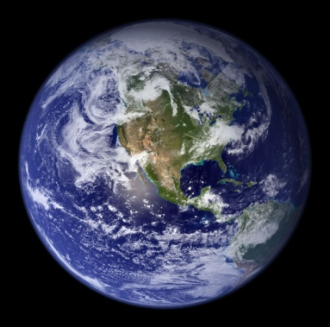  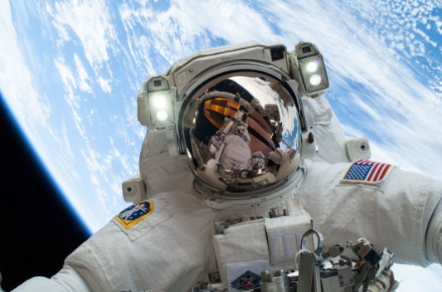  Working with text (reading – speaking – writing)  - Pupils read the paragraph about our solar system. After, they should ask their partners questions so they can fill in the gaps in their text.  Planets  - How many planets are in our solar system? (8)  - Do you know the names of any planets? (We can say it in Czech and then English because it’s very similar and pupils will listen it in next activity - song.)  Solar system song  - https://www.youtube.com/watch?v=mQrlgH97v94  - listen and write down the missing words in text  Speaking  - There is a planned mission to Mars in 2020. What three items do you put inside the spacecraft? Explain your choices.  - 1. part: everyone write 3 things  - 2. part: in group 3-4 people choice from all ideas 3 things  - Every group present their things and say why they should take just these objects.  Conversation cards  - Working in groups  - Every group draw one or two cards, discuss about it and then write a short work about it.  The end of lesson | Aids: pictures (1,2,3), ball  In pairs.  Worksheet for pair.  Attachment 1  Worksheet for everyone.  Attachment 2  In the first time working alone, than in groups.  Attachment 3

Attachment 1
Worksheet AMAZING SPACE

We live on the planet. The name of this planet is Earth. First picture of Earth is from the very last expedition on moon in 1972. The name of expedition is Apollo 17.
In the past, we could only look at the stars and planets through telescopes. Now, we have the technology to find out about these stars and planets more and we can send astronauts into space. The Earth is part of solar system. The solar system is named after the only star in this solar system. It is sun. The sun came into being before 4, 6 billion years. After a time the solar system came into existence from lots of particles. Our solar system includes 8 planets, moons, minor planets, comets, meteoroids, dust particles and space dust.
Student A AMAZING SPACE

We live on the __________. The name of this planet is Earth. First picture of Earth is from the very last expedition on moon in ______. The name of expedition is Apollo 17.
In the past, we could only look at the stars and planets through _______________. Now, we have the technology to find out about these stars and planets more and we can send ___________ into space. The Earth is part of solar system. The solar system is named after the only star in this solar system. It is ____. The sun came into being before 4, 6 billion years. After a time the solar system came into existence from lots of particles. Our solar system includes 8 planets, _______, minor planets, __________, meteoroids, dust particles and ____________.

Student B AMAZING SPACE

We live on the planet. The name of this planet is __________. First picture of Earth is from the very last expedition on moon in 1972. The name of expedition is ________________.
In the past, we could only look at the stars and planets through telescopes. Now, we have the ______________ to find out about these stars and planets more and we can send astronauts into space. The Earth is part of ________ system. The solar system is named after the only star in this solar system. It is sun. The sun came into being before ______________ years. After a time the solar system came into existence from lots of particles. Our solar system includes ___________, moons, _______________, comets, meteoroids, _______________ and space dust.

Sources:

- Obr. 1: Constructing the Space Station. In: NASA [online]. 2006 [cit. 2018-03-28]. Dostupné z: https://www.nasa.gov/multimedia/imagegallery/iotd.html
- Obr. 2: Astronaut. NASA [online]. 2015 [cit. 2018-03-28]. Dostupné z: https://www.nasa.gov/sites/default/files/11572307115_1194957269_o_0.jpg
- Obr. 3: Earth. NASA [online]. 2002 [cit. 2018-03-28]. Dostupné z: https://www.nasa.gov/sites/default/files/thumbnails/image/1-bluemarble_west.jpg

Attachment 2

eight dust Mars smallest biggest planets Neptune atmosphere

life icy planets revolve Mercury Saturn icy chunks mountain

solar system sun Jupiter Uranus Venus Earth second furthest

SOLAR SYSTEM SONG

There are ________planets in our solar system
We all revolve around the ______
Join us to learn about the different ___________
Now sing along and have some fun

My name is ________
I’m the second hottest planet
The closest one to the sun
A year on my surface is 88 days
I’m the ______________ but I’m lots of fun

My name is ________
I’m the hottest planet
But the ________ planet from the sun
I’m the brightest planet in our solar system
And I’m too hot for any one

My name is ________
I’m the planet you live on
The third planet from the sun
I’m the only planet with organic ______
So take care of me because we’re all one

My name is _________
I am red in colour
The fourth planet from the sun
I have the highest ____________ in our solar system
A volcano named Olympus Mons

There are eight planets in our ________ ________
We all ________ around the sun
Join us to learn about the different planets
Now sing along and have some fun

My name is __________ I am covered in clouds
I’m the fifth planet from the sun
My giant red spot is a raging storm
As for size I’m the __________ one

My name is ________ I am brown in colour
I’m the sixth planet from the sun
My outer rings are extremely thin
They’re made of ______ and ____ ________

My name is __________ I am blue in colour
I’m the seventh planet from the sun
Humans have named me the ____ ________
Because I am the coldest one

My name is __________ I am blue in colour
I’m the eighth planet from the sun
I have too many storms in my __________
And I’m the __________ planet from the sun

There are eight planets in our solar system
We all revolve around the sun
Join us to learn about the different planets
Now sing along and have some fun

LETS TALK ABOUT SPACE – conversation cards
When do you think people will visit Mars?
What do you think they will find there?
What is a satellite?
What are they used for?
How would life be different without them?
Name as many planets as you can in English.
Draw them in the correct position to the sun.
Do you think there is other life in the universe? What kind of life? What would aliens look like? Draw them.

Have you ever looked through a telescope?
What did you see?
Do you think we will ever communicate with intelligent aliens? When and how will this happen?
Will the Earth ever be visited by aliens? What would their space ships look like?
Draw a space ship.
Would it be a good idea to build a permanent base on the moon?
Why or why not?
Should we try to discover other planets and life forms?
Why or why not?
Would you like to be an astronaut?
Explain why or why not.
How and when was the universe created?
What was there before it existed? Discuss.
Do you think people will ever take holidays in space?
Describe how you think this will work.

What is the speed of light?
How is distance measured in the universe?
What is your favourite sci-fi movie or TV show?
Tell the plot.
How big is the universe?
How long would it take to travel to another galaxy?
Research and discuss.
Do you think governments spend too much or too little on space exploration?
Explain your view.
Should money be spent on space programmes while there is still so much poverty on Earth?
Explain your point of view.
What do you think the odds are of Earth being hit by a meteor?
Should we develop protection systems for this possibility?

Sources:

- Song and lyric: https://www.youtube.com/watch?v=mQrlgH97v94
- https://en.islcollective.com/resources/printables/worksheets_doc_docx/lets_talk_about_space/questions-debate-lets/4116
- Obr. 1: Constructing the Space Station. In: NASA [online]. 2006 [cit. 2018-03-28]. Dostupné z: https://www.nasa.gov/multimedia/imagegallery/iotd.html
- Obr. 2: Astronaut. NASA [online]. 2015 [cit. 2018-03-28]. Dostupné z: https://www.nasa.gov/sites/default/files/11572307115_1194957269_o_0.jpg
- Obr. 3: Earth. NASA [online]. 2002 [cit. 2018-03-28]. Dostupné z: https://www.nasa.gov/sites/default/files/thumbnails/image/1-bluemarble_west.jpg

